AI Crawler Tar Pits: Machine Learning Approaches for Botnet and AI Crawler Detection

MSC Computer Science
Name: Zaighum Hassan
Student Id: S301492
Submission Date: 05 January 2026
Supervisor: Chris Hewes-Lewington
Abstract
This research examines the challenge of bad AI-controlled crawlers and suggests the AI Crawler Tar Pits as a defence model that allows identifying and confining automated adversarial actors prior to retrieving extensive information. The article is based on the CTU-13 botnet dataset as an experimental proxy on crawler behaviour and forms a machine learning model to categorise normal and malicious network traffic. This research applied 5 algorithms, i.e., Random Forest, XGBoost, LightGBM, Gradient Boosting, and AdaBoost. Extensive exploratory data analysis has elaborated the presence strong indicators of behavioural differences in real time between benign traffic and botnet traffic through of timing irregularities, packet rates, duration of flow, variation in packet size and protocol flag activity. The models yielded high scores of predictive accuracies, attaining the highest accuracy of 99.84% with XGBoost, while the rest of the models demonstrated comparable results. The analysis of the correlation of features and importance indicates that SYN flag count, packet rate, inter-arrival time statistics and variability in packet length have high correlativity as discriminative features.
The thesis goes beyond the classification and makes a mapping of these results to an operational defence strategy. A Tar Pit framework based on confidence is proposed, with the model prediction probabilities being converted to graduated response levels between benign access and complete entrapment and deception. This contribution shows that botnet detection models can be applied to both label traffic and provide information for automated containment against AI crawlers. The study thus connects intrusion detection, behavioural analysis and adaptive response to a single system of data ingestion environment protection.

Acknowledgements
Without the unwavering love and support of my family, I would never have had the confidence to face the challenges of this journey. I can't express how much I appreciate your sacrifices and steadfast support.
I am appreciative of my best buddy, who has consistently helped me, comforted me, and inspired me to keep going even in the most difficult circumstances. Your belief in me had a significant impact. I would want to thank my supervisor for their constant encouragement, support, and helpful critique during this task. Additionally, they responded to my many letters and questions with a great deal of compassion and patience.
Finally, I would want to express my gratitude to the institution for providing me with the opportunity, resources, and supportive learning environment that enabled me to finish this program and this report.

Table of Contents
Acknowledgements 3
List of Figures 8
List of Abbreviations 9
Chapter 1 - Introduction 10
1. Introduction 10
1.2 Research Aim & Objectives 11
1.2.1 Aim 11
1.2.2 Objectives 11
1.3 Research Questions 11
1.4 Security Context & Relevance 11
1.5 Definitions of Key Concepts 12
Chapter 2 Review of Literature 12
2.1 Introduction 12
2.2 The CTU-13 Benchmark: A “Double-Edged Sword” in Botnet Detection Research 13
3. Review of Machine Learning Approaches 14
3.1 Standalone & Simple Models 14
3.2 Decision Tree Models 14
3.3 Ensemble & Boosting Models 15
3.4 Methodological Justification 16
4. Deep Learning Architectures 16
5. Hybrid Architectures and Advanced Paradigms in Threat Detection 17
5.1 Graph-Based Models 17
5.2 Reinforcement Learning Methods 18
6. Gap Analysis of Current Studies 18
6.1 Identified Gaps 18
6.2 Research Contribution & Novelty 19
Chapter 3 – Research Methodology 21
3.1 Introduction of Chapter 21
3.2 Sequence of the Applied Method 21
3.3 Complete Walkthrough of Methodology 22
3.3.1 Data Ingestion Module 22
3.3.2 EDA Module 22
3.3.3 Preprocessing Module 22
3.3.3.1 Missing-Value Imputation 22
3.3.3.2 Dataset Scaling 23
3.3.4 Model Development Module 23
3.3.4.1 Selection Approach of “X” and “Y” Values 23
3.3.4.2 Dataset Splitting Strategy 23
3.3.4.3 Model Initialisation Strategy 24
3.3.4.4 Model Fitting Stage 24
3.3.4.5 Model Evaluation Stage 25
3.4 Selection Method Machine Learning Models 26
3.4.1 Random Forest Classifier 26
3.4.2 XGBoost Classifier 26
3.4.3 LightGBM Model 27
3.4.4 AdaBoost Classifier 27
3.4.5 Gradient Boosting Classifier 28
3.5 Selection of Dataset 28
3.5.1 Brief Description 28
3.5.2 Relevancy of Dataset & Justification 29
3.6 Programming Language Selection 29
3.7 Conclusion 29
Chapter 4 – Analysis & Development of Model 30
4.1 Introduction of Chapter 30
4.2 Developmental Workflow of Machine Learning 30
4.2.1 Importing Python Packages 30
4.2.2 Loading Dataset 31
4.2.3 Understanding Dataset Structure 31
4.2.4 Exploratory Data Analysis (EDA) 32
4.2.4.1 Basic Information of Dataset 32
4.2.4.2 Class Distribution Analysis 33
4.2.4.3 Feature Distribution Analysis 33
4.2.4.4 Analysis of Highly Correlated Features 35
4.2.4.5 Using Analysis for Feature Selection 35
4.2.5 Dataset Preprocessing 36
4.2.5.1 Checking & Removing Unnecessary Columns 36
4.2.5.2 Checking Infinite Values 37
4.2.5.3 Missing Value Analysis in Dataset 38
4.2.6 Selection of “X” and “Y” Values 38
4.2.7 Splitting Dataset into Train & Test 39
4.2.8 Scaling of Training & Testing Datasets 39
4.2.9 Initialising Machine Learning Models 40
4.2.9.1 Hyperparameters of ML Models 40
4.2.9.2 Fitting Machine Learning Models 41
4.3 Conclusion of Chapter 43
Chapter 5 – Results of Models 44
5.1 Chapter’s Introduction 44
5.2 Overall Results of All Models 44
5.2.1 Results of “Random Forest” 44
5.2.2 Results of “XGBoost Classifier” 45
5.2.3 Results of “Gradient Boosting Classifier” 45
5.2.4 Results of “AdaBoost Classifier” 45
5.2.5 Results of “Light GBM Classifier” 46
5.3 Comparative Analysis of Models’ Results 46
5.3.1 Bar Chart Analysis 46
5.3.2 Confusion Matrices of Models 47
5.3.3 Tabular Analysis of Results 48
5.3.4 Reasoning of High Accuracy on Dataset 48
5.4 Security Interpretation of Results 49
5.5 Research Novelty Mapping Results to “Tar Pits” 49
5.5.1 Behavioral Signature Analysis: Botnets vs AI Crawlers 49
5.5.2 Tar Pit Detection Triggers 50
5.5.3 Tar Pit Response Strategy 51
5.6 Conclusion 51
Chapter 6 – Conclusion & Recommendations 52
6.1 Conclusion 52
6.2 Project Development Process & Reflection 52
6.3 Future Work & Recommendations 53
7. References 53

List of Figures
Figure 1: Methodology Applied by (Hostiadi et al., 2025) 13
Figure 2: Architectural Overview of Methodology 19
Figure 3: Dataset Splitting Strategy 22
Figure 4: Stage of Model Fitting & Evaluation 22
Figure 5: Visual Analysis of Applied ML Models 26
Figure 6: Importing Python Packages 28
Figure 7: Dataset Loading in Workspace 29
Figure 8: Dataset Samples 29
Figure 9: Dataset Structure (First 5 Rows) 30
Figure 10: Basic Info from Data 30
Figure 11: Class Distribution Analysis 31
Figure 12: Feature Distribution Analysis 32
Figure 13: Highly Correlated Features 33
Figure 14: Removing Unnecessary Columns 34
Figure 15: Removal of Unnecessary Column 35
Figure 16: Checking Infinite Values 35
Figure 17: Missing Value Analysis 36
Figure 18: Selection of “X” & “Y” Values 36
Figure 19: Dataset Splitting 37
Figure 20: Feature Scaling on Train & Test 37
Figure 21: Fitting Random Forest 39
Figure 22: Fitting XGBoost Model 39
Figure 23: Fitting LGBM Model 40
Figure 24: Fitting AdaBoost Model 40
Figure 25: Fitting Gradient Boosting Model 40
Figure 26: Results of Random Forest Model 42
Figure 27: Results of XGBoost Model 43
Figure 28: Results of Gradient Boosting Model 43
Figure 29: Results of AdaBoost Classifier 43
Figure 30: Results of LGBM Model 44
Figure 31: Confusion Matrices of Models 45
Figure 32: Tar Pit Behavioural Signatures 47
Figure 33: Detection Triggers for Tar Pits 48
Figure 34: Confidence-Based Response Framework 48

List of Tables
Table 1: Tabular Analysis of Past Studies 18
Table 2: Data Imputation Approaches 20
Table 3: Selection of Python Libraries 27
Table 4: Hyperparameter Setting of ML Models 38
Table 5: Performance Comparison of Machine Learning Models on CTU-13 Dataset 46

List of Abbreviations
Abbreviation | Full Form
AI | Artificial Intelligence
ML | Machine Learning
DL | Deep Learning
RF | Random Forest
GBM | Gradient Boosting Machine
XGBoost | Extreme Gradient Boosting
LightGBM | Light Gradient Boosting Machine
AdaBoost | Adaptive Boosting
SVM | Support Vector Machine
KNN | k-Nearest Neighbours
MLP | Multilayer Perceptron
CTU-13 | Czech Technical University Botnet Dataset
ROC | Receiver Operating Characteristic
AUC | Area Under the ROC Curve
TP | True Positive
TN | True Negative
FP | False Positive
FN | False Negative
FPR | False Positive Rate
TPR | True Positive Rate
F1 | F1-score
MCC | Matthews Correlation Coefficient
EDA | Exploratory Data Analysis

Chapter 1 - Introduction

1. Introduction
Autonomous data collection and ingestion pipelines lie at the heart of many modern artificial intelligence systems (Steidl, Felderer and Ramler, 2023). As organisations and researchers increasingly rely on large-scale automated acquisition of data for training, monitoring, or inference tasks, the design and robustness of those pipelines become critical. One emerging risk, seldom addressed in structured research, is the phenomenon of gradual degradation, inefficiency, bias reinforcement, redundancy accumulation, and resource escalation, here referred to as “AI Crawler Tar Pits”. The metaphor emphasises how even intelligent, adaptive retrieval systems can become stuck in self-reinforcing inefficiency, reminiscent of software development “tar pits”.
To investigate these risks concretely, this research adapts the idea of “crawler tar pits” to the domain of network traffic ingestion and analysis, by using the “CTU-13 Dataset”. We propose a new working dataset designation, CTU-13 Dataset, tailored to study how data ingestion pipelines, similar in structure to web-crawlers or autonomous agents, may degrade when repeatedly ingesting large volumes of network traffic and applying machine-learning-based filtering or classification.
The “CTU-13” dataset is a collection of real-world network traffic traces created in thirteen situations at the “Czech Technical University (CTU)” and consisting of botnet traffic, normal traffic, and background traffic (The CTU-13 Dataset. A Labeled Dataset with Botnet, Normal and Background traffic., 2025). The various scenarios are associated with the various malware or botnet family, and records of those sceneries have been extensively utilised in botnet detecting studies. Its realism, variety, and naming make it a potent base to simulate the ingestion and classification pipes that may be like AI crawlers. This study seeks to identify structural and functional reasons resulting in poor ingestion quality using CTU-13-TarPitNet and is reminiscent of the dynamics seen in the web-scale crawling of tar-pits.
This research is timely and relevant. As cyber-security, intrusion detection, and anomaly detection systems increasingly incorporate automated data pipelines and self-training models, the risk that such systems may gradually degrade or entrench bias becomes significant. Understanding “tar pit” phenomena in this context can guide the design of more robust, efficient, and maintainable data-driven AI systems.
This proposal details a plan to deliver a conceptual framework, empirical evidence, and practical mitigation strategies rooted in real-world network traffic data.

1.2 Research Aim & Objectives

1.2.1 Aim
- To investigate and characterise the emergence of “tar-pit” phenomena in long-term automated data-ingestion and classification pipelines, using the CTU-13-TarPitNet dataset as a concrete case study, and to propose and evaluate design strategies that mitigate redundancy, data drift and performance degradation.

1.2.2 Objectives
- To implement and simulate multiple ingestion-classification pipeline configurations on CTU-13-Daatset, mimicking real-world autonomous data ingestion.
- To perform repeated ingestion cycles, including normal, perturbed, and drift-injected data batches to observe how pipeline configurations behave over time under evolving data distributions.
- To statistically compare the performance of different models with respect to both classification effectiveness (precision, recall, F1-score, AUC) and long-term efficiency/diversity metrics.

1.3 Research Questions
- Under what conditions do automate ingestion-classification pipelines begin to exhibit tar-pit phenomena (e.g., increasing redundancy, declining novelty, resource inefficiency) when processing network-traffic data?
- How do different pipeline configurations, in particular deduplication filtering, diversity-aware sampling, and periodic retraining, influence the onset, severity, and trajectory of tar-pit conditions?
- What trade-offs arise between classification performance (detection of malicious flows) and long-term pipeline health (data diversity, resource usage, redundancy)?
- How does the injection of data drift or scenario perturbation (e.g., new botnet families, altered traffic patterns) affect pipeline stability and tar-pit indicators under different configurations?

1.4 Security Context & Relevance
Uncontrolled automated crawlers and botnet-driven traffic pose a serious threat to contemporary digital systems from the standpoint of information security. Such traffic can threaten confidentiality by scraping sensitive or proprietary data on a wide scale, undermine availability by depleting computing and network resources, and harm integrity by continually inserting malicious or biased data into AI-driven ingestion pipelines. Malicious automated agents provide long-term degradation threats that go beyond typical intrusion events as businesses depend more and more on machine learning systems that continuously consume data.
As a result, this project presents malicious crawler identification as a defensive security measure rather than just a classification effort. By facilitating early detection, controlled response, and containment of malicious automation, the goal is to enable secure system operation. The study addresses new risks to data-driven infrastructures while explicitly adhering to fundamental security principles by combining machine learning with an operational response architecture in the form of an AI-driven tar pit.

1.5 Definitions of Key Concepts
The term "repeated ingestion" describes how automated systems continuously or cyclically process same or similar traffic patterns over several operating or learning cycles. Repeated ingestion becomes troublesome in security scenarios when rogue crawlers submit automated queries frequently, affecting downstream analytics and learning processes or gradually deteriorating system performance.
Data batches that exhibit gradually changing traffic characteristics over time either spontaneously or as a result of adaptive attacker behavior are known as drift-injected batches. These batches are used to mimic idea drift, a problem for long-term security monitoring systems that occurs when previously learnt patterns become less indicative of current circumstances.

Once harmful automated agents are identified, an AI crawler tar pit is a defensive security measure that purposefully delays, reroutes, or confines them. Tar pits, as opposed to conventional blocking techniques, seek to maintain regular service availability while reducing the effectiveness of attackers and gathering behavioural intelligence.

Chapter 2 Review of Literature

2.1 Introduction
AI crawler systems are autonomous pipelines that collect and ingest large volumes of data (e.g. network flows or web pages) for analysis (Kadel et al., 2024). Such systems must continuously process new information, but this exposes them to ingestion risks, for example, repeatedly encountering the same malicious or irrelevant content. The “tar-pit” analogy is used to describe how crawlers can become mired in such pitfalls. In software engineering, a “tar pit” refers to a situation where tasks become intractably complex, and progress slows to a crawl (Wan, Li and Sun, 2019). In the context of network crawling, “botsites” or sinkholes can trap crawlers in loops of redundant or malicious data. For AI crawlers, ingesting repeated botnet traffic can similarly bog down learning pipelines, leading to inefficiency and degraded performance over time.
Against this backdrop, botnet detection is a foundational defensive strategy for crawlers. By identifying and filtering out botnet-infected traffic, crawlers avoid processing harmful or redundant data (Wan, Li and Sun, 2019). Botnet traffic often exhibits distinctive patterns, making classification feasible with machine learning (Ahmadi, 2025). Indeed, ML-based detectors (e.g. on the CTU-13 dataset of botnet traffic) can separate malicious flows from benign ones with high accuracy (Suchacka et al., 2021). In turn, these classifiers can form the core of a crawler’s defence: any flow flagged as botnet can be downweighed or discarded, preventing the crawler from becoming ensnared in tar-pit loops. In summary, the ability to detect botnet traffic is critical to designing resilient AI crawlers that maintain throughput and avoid the trap of repetitive malicious content.

2.2 The CTU-13 Benchmark: A “Double-Edged Sword” in Botnet Detection Research
The CTU-13 data has become an icon in the botnet detection research field, being referenced in many systematic and primary studies published from 2020 through 2025 (Wazzan et al., 2021); (Hernandez-Ramos et al., 2025). The factors that contribute to its long-standing popularity are some of the distinguishing features that make it a useful tool in developing the initial models and making comparisons. The dataset, curated by the Czech Technical University, consists of thirteen different scenarios, which simulate network traffic that has been caused by seven different malware families, Neris, Rbot, Virut, DonBot, Sogou, Murlo, and NSIS, which were run in a sandboxed university network environment in the months of August and September 2011 (The CTU-13 Dataset. A Labeled Dataset with Botnet, Normal and Background traffic., 2011); (Mvula et al., 2023).
One of the strengths of the CTU-13 is that it includes actual malware traffic, hence providing more realistic patterns as opposed to purely synthetic datasets (Goldschmidt and Chudá, 2025). All the scenarios were thoroughly analysed and annotated on the NetFlow level, and traffic has been divided into 3 classes: Botnet (C&C channels, in particular), Normal (bona fide user traffic), and Background (unclassified traffic) (Ryu and Yang, 2018a). This universal labelling is essential to monitored machine learning, and it is possible to train classifiers that will be able to differentiate between malicious and benign flows with high fidelity. Besides, the dataset includes traffic of different protocols such as HTTP/HTTPS, DNS, ICMP, and UDP, which gives a multi-dimensional picture of botnet activity that is critical to the creation of holistic detection models.
A wide range of models have been able to achieve extremely high results with almost perfect accuracy, taking CTU-13 dataset as foundation. As an illustration, the XGBoost classifiers have been reported with more than 99 per cent accuracy on the data with salient features like maximum packet size and TLS version, reported as key discriminators of malicious traffic (Zeleke, Jember and Bochicchio, 2025). Similarly, ensemble methods, including Random Forest, have demonstrated better accuracy as well as training time than simpler classifiers (Ryu and Yang, 2018b), as well as deep-learning models, including Transformers, have demonstrated accuracies above 99.8% with complementary models like CNN-BiLSTM (Gamage et al., 2025). In addition, other dedicated architectures such as DETD (Deep Encrypted Traffic Detection) have reported an accuracy of 99.9984 on CTU-13 based on the focus on encrypted traffic without the need to decrypt it (Long and Zhang, 2023).
These impressive results provide a very solid foundation for the researchers, meaning that with the proper availability of computational facilities and careful feature engineering, it is possible to achieve the high-quality classification with this dataset. Therefore, CTU-13 can be regarded as a valuable tool in the process of benchmarking new algorithms, as well as comparing their effectiveness with conventional standards.
However, this strong success can provide an illusion of strength. The utility of the dataset is drastically reduced due to its fundamental limitations, and it is not a suitable standard to build truly resilient AI crawlers that can be applied in the real world. These constraints are basic incompatibilities with autonomous crawling operational reality, thus creating significant disorientation between the laboratory performance and the practicability.

3. Review of Machine Learning Approaches

3.1 Standalone & Simple Models
The body of research applying machine learning (ML) and deep learning (DL) to botnet detection reveals a spectrum of techniques, each with distinct strengths and weaknesses relevant to the challenges faced by AI crawlers. Simple and standalone models, such as Logistic Regression, Support Vector Machines (SVM), k-Nearest Neighbors (KNN), and Naive Bayes, serve as important baselines for evaluating more complex architectures (Martínez Llamas et al., 2025a). On the CTU-13 dataset, these models often struggle with the inherent class imbalance and complexity of the traffic. For example, (Sinha et al., 2025a) reported that an SVM achieved only 63% accuracy and 65% recall, while Naïve Bayes scored 85% accuracy but suffered from a high false positive rate of 87%.
Classical supervised classifiers have long been applied to botnet traffic detection. Logistic Regression, SVM, KNN, and Naive Bayes are often used as baseline models on datasets like CTU-13 or IoT flows. For example, (Siswanto et al., 2025a) found that SVM achieved 95.2% accuracy on an IoT botnet dataset, outperforming Naive Bayes (89.6%) and logistic regression (91.8%). Similarly, comparative studies on CTU-13 show SVM often attains the highest overall accuracy, though its high accuracy sometimes comes at the cost of low recall on minority classes (International Journal of Intelligent Engineering and Systems, 2025). In one evaluation, an SVM scored 97.94% accuracy on CTU-13 but only 68.0% recall, whereas a decision tree had lower accuracy of around 94%, but far better recall, which was 88.5%.
Other simple classifiers have been used as well, i.e., K-Nearest Neighbours and Naive Bayes are popular for their simplicity. Naive Bayes tends to be fast but less accurate, a study by (Padhiar and Patel, 2023a) reports the average accuracy of Naive Bayes as low as 86.79% on some CTU-13 scenarios, far below decision trees, which was 95.91%. In IoT contexts, Naive Bayes often lags tree models. KNN has been applied (sometimes with feature normalisation) but suffers at scale, since the CTU-13 flows number in the millions, making KNN computationally heavy. Logistic regression provides probabilistic outputs and works well on balanced data; in practice it often yields solid accuracy but usually underperforms nonlinear models like SVM or trees when the data have complex decision boundaries.

3.2 Decision Tree Models
Decision trees (e.g. C4.5, CART) are widely used for botnet detection because of their interpretability and handling of mixed features (Canavese et al., 2022). They learn flow-based splits that partition normal vs botnet traffic. In CTU-13 benchmarks, decision trees typically achieve very high precision and recall, especially for minority classes, like (Padhiar and Patel, 2023a) reported that a decision tree on CTU-13 achieved ~96% accuracy across scenarios, far outperforming Naive Bayes in those tests. Critically, in (Hostiadi et al., 2025), the decision tree on CTU-13 attained 81.2% F1 (i.e., precision 75.0%, recall 88.5%) Vs performance of SVM, which was 65.0% F1, demonstrating that trees capture the botnet class more reliably.
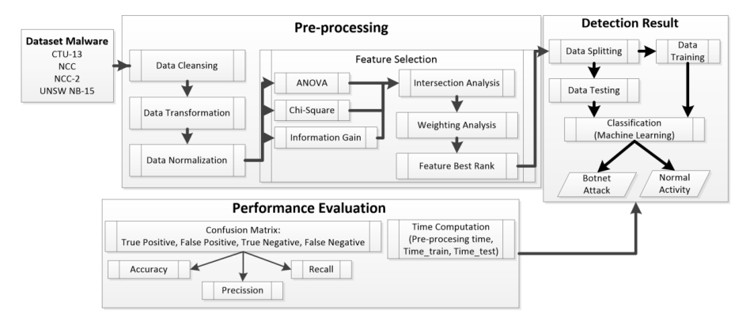
Figure 1: Methodology Applied by (Hostiadi et al., 2025)
However, decision trees have limitations, in which overfitting on noisy data and instability are prominent, small changes in traffic distribution may produce very different tree structures, as seen in (Hostiadi et al., 2025); (Czajkowski and Kretowski, 2019). In highly dynamic network traffic, a single deep tree may not generalise. Trees also do not inherently model temporal behavior; they view each flow in isolation. If botnet patterns evolve, a static decision tree may fail to adapt. Moreover, trees can fragment data too finely, in some CTU-13 studies, deep trees split many flows incorrectly when attacked by evasive bots, yielding false negatives. In summary, while decision trees excel at capturing static, behavior-based rules, as shown by near-perfect accuracy in offline tests in (Padhiar and Patel, 2023b), they are sensitive to scenario details and can overfit to specific traffic structures.

3.3 Ensemble & Boosting Models
In contrast, ensemble methods, which combine multiple models to improve performance, have shown greater promise. Random Forest has, more specifically, been highlighted for outperforming other classifiers in both accuracy and training speed on CTU-13, demonstrating its suitability for handling imbalanced data through implicit feature selection (Ryu and Yang, 2018c). Similarly, XGBoost models have achieved accuracies of 99.32% on custom encrypted malware datasets, showcasing the power of gradient boosting in this domain (Nibret Zeleke, Fentie Jember and Bochicchio, 2025). These models are computationally efficient and relatively interpretable, making them suitable candidates for real-time, resource-constrained environments or as part of a cascading defence architecture within an AI crawler. However, their reliance on handcrafted features can limit their ability to capture highly complex, non-linear patterns present in modern botnet traffic.
In botnet detection, random forest has often achieved state-of-the-art results, for example, (Rauf Ali Khan et al., 2025) evaluated RF, AdaBoost, XGBoost, LightGBM on IoT traffic and found RF achieved almost perfect accuracy, higher than all other models tested. In CTU-13 scenarios, (Patil and Deshpande, 2023) also found RF achieved ~99.0% accuracy on a large IoT-23 dataset, surpassing KNN and Naive Bayes.
Boosting algorithms like XGBoost, LightGBM, and AdaBoost have likewise shown excellent performance on botnet data. Often, a tuned XGBoost slightly beats RF. For instance, (Alrakah et al., 2025) optimised XGBoost on CTU flows and reported ~99.2–99.6% accuracy with careful feature selection. Another work by (Han, Wei and Huang, 2024) proposed a SMOTE‑XGBoost model for industrial IoT quality monitoring and reported near‑perfect classification performance on their manufacturing dataset. Gradient Boosting Machines (i.e., LGBM, XGBoost) similarly yield high detection rates when feature sets are well-chosen. The key advantage of ensemble learning methods is their ability to reduce variance by mitigating overfitting of individual trees.

3.4 Methodological Justification
Because tagged network traffic data is readily available and supervised classification has a well-established function in intrusion detection systems, the research uses a supervised machine learning approach. In security applications, where it is crucial to differentiate between benign and hostile conduct and where false negatives can have serious operational repercussions, supervised learning is especially well suited.
Because of their resilience against overfitting, robustness, and capacity to simulate intricate non-linear interactions, ensemble and boosting-based algorithms were chosen. These qualities are particularly useful in security scenarios, where detection systems need to be able to generalise beyond particular attack signatures and attacker conduct can change significantly over time.

The CTU-13 dataset was selected because it has been used extensively in intrusion detection research and comprises actual botnet traffic recorded under realistic network settings. Despite the dataset's age, its labelled structure and variety of malware scenarios make it suitable for assessing the viability of machine learning-based crawler detection in a controlled academic environment.

4. Deep Learning Architectures
To address the limitations of more primitive architectures, deep-learning architectures have become the most common paradigms, with the highest results on benchmark tasks, including CTU-13. RNNs, along with their variants, such as Long Short-Term Memory (LSTM) networks and Gated Recurrent Units (GRUs), prove to be highly capable in the sequential data processing, which makes them especially suitable in revealing temporal dependencies in network traffic flows (Martínez Llamas et al., 2025b).
Empirical studies find that LSTM networks can achieve accuracies closer to 92 toward the CTU-13 test, with the aid of the exploitation of the time-series properties of the inter-arrival times and the packet lengths (Sinha et al., 2025b).
The Transformer architecture and the use of self-attention mechanisms have emerged of late as powerful tools to identify complex, long-range patterns. Several papers from 2022 to 2025 report F1 scores to 99% on CTU-13, often by combining transformers with either convolutional neural networks (CNNs) or LSTMs to capture local and global features at the same time [21]. As an example, the highest accuracy of a Transformer + CNN-BiLSTM model was 99.84 per cent, and recall was 99.8%, and the highest accuracy of the “Transformer + MLP” configuration was 99.97% (Gamage et al., 2025). Although such models also exhibit impressive pattern-recognition performance, their implementation in an AI crawler setting presents a set of issues associated with computational complexity, latency, and the lack of transparency in decision-making, thus making it harder to debug and trust their decisions (Zhang et al., 2025).
An alternative approach is unsupervised learning involving autoencoders. Autoencoders are trained on compressions of normal traffic and can indicate anomalies, which make them effective towards identifying new variants of botnets do not present in the training data. This is vital to an AI crawler that faces zero-day threats, but methods that are not supervised can fail when faced with high-dimensional streaming data (Zhou, 2025).

5. Hybrid Architectures and Advanced Paradigms in Threat Detection
While individual machine learning and deep learning models have demonstrated impressive capabilities, the most resilient defence systems are often built upon hybrid architectures that integrate multiple techniques to overcome the limitations of any single approach. One prominent direction is the fusion of ML with statistical anomaly detection and clustering algorithms. This approach leverages the pattern-recognition strengths of ML classifiers while incorporating the robustness of statistical methods to identify outliers and group similar events 8. For instance, an unsupervised online anomaly detection model implemented with the river library’s One-Class SVM achieved 98.4% accuracy and 100% recall on NF-UNSW-NB15-v2, capable of processing network flows in real-time (<0.033 ms per flow) and adapting to concept drift without retraining 23. This is particularly valuable for AI crawlers, as it allows for the continuous filtering of repetitive or low-risk traffic before it reaches downstream indexing systems, reducing noise by over 80% in some cases 8. Such pipelines enable real-time prioritization and significantly accelerate mean time to detection and response, providing empirical validation for the importance of monitoring pipeline health metrics like signal-to-noise ratio and enrichment latency 8.

5.1 Graph-Based Models
Another transformative paradigm is the application of graph-based methods, which shifts the focus from analyzing individual network flows to understanding the relationships between entities. Graph Neural Networks (GNNs) model network communications as graphs, where nodes represent hosts (IP addresses) and edges represent connections, allowing the system to detect coordinated, multi-hop behaviors that appear benign at the flow level 5253. This is directly analogous to identifying crawler entrapment patterns, such as distributed scanning campaigns or lateral movement, which manifest as complex, relational anomalies rather than isolated malicious packets.
Research has shown that graph-level analysis of CTU-13 data can achieve up to 95% accuracy, compared to just 50% for flow-level baselines, underscoring the power of this approach 53. The NCC-G dataset, which reprocesses CTU-13 into host-centric graphs, further confirms this by demonstrating superior cluster separation between botnet and normal traffic, validating the enhanced signal-to-noise for pipeline health monitoring 36. Modular cloud intrusion detection frameworks are now explicitly combining GNNs for relational modeling with Transformer-based autoencoders for contextual refinement and contrastive learning to enforce inter-class separation in the latent space, achieving average accuracy above 99.9% on datasets like CICIDS2018 52. This holistic approach, which uses graph representations to capture coordinated behaviors and contrastive learning to build resilience against concept drift, offers a direct blueprint for mitigating the feedback loops and redundancy traps that lead to crawler tar pits 52.

5.2 Reinforcement Learning Methods
In addition to these architecture combinations, more sophisticated paradigms based on reinforcement learning and adversarial resilience are pushing the boundaries of the possible results. Adversarial Resilience Learning (ARL) is a conceptualisation that views the relationship between a crawler and a defender and an attacker and a botnet as a conflict between two non-cooperative entities in a cyber-physical system (e.V, 2025). Within this context, the attacker actively explores the system to identify its vulnerabilities, whereas the defender continuously learns about the attacks made on him/her to maintain a resilient operation.
This architecture requires the creation of strong strategies outperforming classical machine learning through the simulation of an evolving arms race and through the explicit modelling of the emergent complexities of crawler-adversary interactions (e.V, 2025). As such, it concurs with the emerging understanding as to the need to have defensive mechanisms in place. Instead of responding actively to threats by being defensive in a passive way, the defence component of a resilient crawler may actively adapt itself to adversarial evasion by creating and testing adversarial examples.
An example of such an approach is the DReLAB dataset, which consists of thousands of realistic evasion samples produced by deep reinforcement learning against classifiers trained on CTU-13 (Venturi et al., 2020). It proves that adaptive adversaries can overpower even high-performance models, which highlights the need to introduce adversarial training into a development lifecycle (Apruzzese et al., 2022). Moreover, the self-healing pipelines of data are also a practical implementation strategy.
This approach includes three basic elements: “dense observability”, “advanced detection”, and “controlled automation” (METHODOLOGIES FOR SELF-HEALING DATA PIPELINES USING AI | The AI Journal, 2025). Using these elements to coordinate with each other, a crawler can proactively track its own health, cure schema drift or data-quality gaps or reduce manual intervention, which increases trust and resilience in its data products. Together, these hybrid and advanced paradigms go beyond mere classification, paving the way for intelligent, adaptive, and self-maintaining systems that can thrive in hostile digital ecosystems.

6. Gap Analysis of Current Studies

6.1 Identified Gaps
Despite extensive research on botnet classification, significant gaps remain relative to the needs of AI crawling pipelines, in which “static evaluation predominates” is at the top. Virtually, all cited studies train and test on fixed datasets (CTU-13, BoT-IoT, N-BaIoT, etc.) without simulating the continuous ingestion environment. For example, (Padhiar and Patel, 2023a) trained on CTU-13 scenarios and reported results per scenario but did not consider what happens when the same flows reappear over time. In practice, crawlers ingest streams repeatedly, so a model must handle repeated exposure to old patterns. The literature has almost no experiments that model “repeated ingestion” or streaming data feedback. The only exception is very recent work by (Agrawal, 2025), which incorporates online retraining for concept drift, but this is rare. Thus, we lack understanding of how static-trained classifiers degrade under continual deployment (e.g. due to concept drift or confirmation bias).
A notable deficiency in the existing literature is the absence of a tar pit mechanism integrated with dataset classification. While numerous studies have achieved impressive classification performance on these datasets, none has explicated how their findings contribute to formulating mechanisms for injecting or activating tar pits targeted at web crawlers, thereby impeding progress in the field.

6.2 Research Contribution & Novelty
Considering the extant literature and its identified limitations, this study achieves exceptional accuracy on the “CTU” dataset while introducing mechanisms to activate tar pits for web crawlers. It further develops a response strategy for AI crawler and botnet pattern detection, employing explainable AI techniques informed by machine learning model outputs. By leveraging these strategies alongside classification results, the research transcends botnet categorisation to propose a tar pit detection framework, addressing a critical gap in prior work.

Table 1: Tabular Analysis of Past Studies
Author(s) / Year | Method | Results (Accuracy) | Gaps
Huo et al. / 2022 | CNN | 90.69% | Evaluation cost and lack of deployment noted as limitations.55
Zhang et al. / 2023 | Extra Trees + Feature Selection | 99% | Static, non-repetitive evaluation; generic flow-level features.45
Khan et al. / 2025 | BEFSONet (Hybrid) | 97.99% | Evaluated on IoT-23, not CTU-13.19
Wang et al. / 2025 | Transformer + CNN-BiLSTM | 99.84% | High computational cost of DL models.21
River Library Study | One-Class SVM (Online) | 98.4% | Designed for online, real-time deployment with concept drift handling.23
(Siswanto et al., 2025b) | SVM, Naive Bayes, LR (Bot-IoT dataset) | 95.2% (SVM) | IoT dataset only; high SVM accuracy but recall imbalance not addressed
(Alrakah et al., 2025) | Random Forest (two IoT botnet datasets) | RF outperforms all others | No details on dataset specifics in abstract

Chapter 3 – Research Methodology

3.1 Introduction of Chapter
The current chapter underlines the entire methodological flow used for developing machine learning models for classification of botnets and defining a mechanism for “tar pits”. The workflow of methodology takes a reference from a flow of machine learning process that incorporates multiple stages, such as data inputs, preprocessing, analysis on the dataset for extracting insights, initialising, and fitting of algorithms, and evaluations. Moreover, this chapter will also underline the selection criteria and reasoning behind the selection of learning algorithms, dataset, plus the justification of the approaches that are applied.

3.2 Sequence of the Applied Method
This methodology follows a “module-based” strategy, in which each developmental stage is split into multiple modules based on the type of operation performed on the dataset (e.g., input, preprocessing, evaluation, etc.). More specifically, the methodological process is divided into multiple modules such as:
- Data Ingestion Module
  - Acquiring and Loading Dataset
- EDA Module
  - Comprising Crucial Analysis to Gain Insights
- Data Preprocessing Module
  - Making Dataset Ready for Modelling
- Model Development Module
  - Initialising, Training & Evaluating ML Models
- Application of Explainable AI
  - Mapping Classification Results to Tar Pits
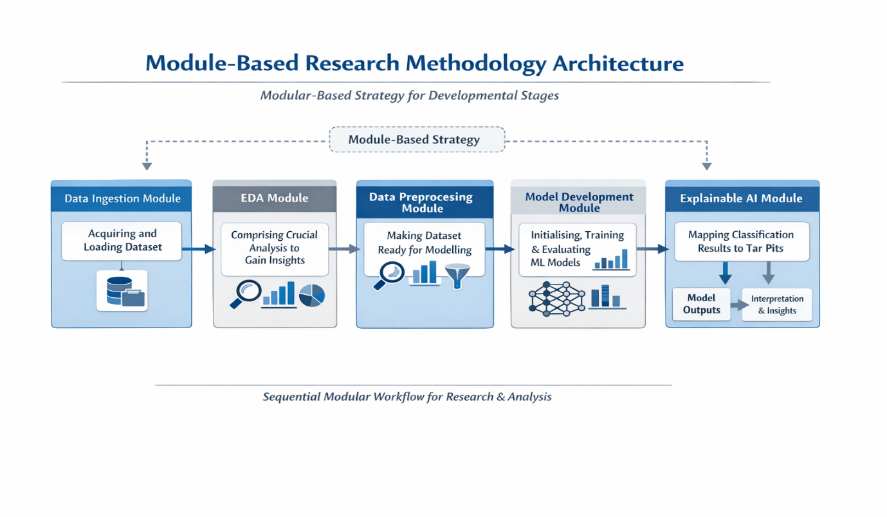
Figure 2: Architectural Overview of Methodology

3.3 Complete Walkthrough of Methodology

3.3.1 Data Ingestion Module
The “data ingestion module” is aimed at acquiring and loading the desired dataset into memory using a programming language. The acquired dataset is expected to contain a lot of samples from normal and partner attacks to make a classification model for initiating a strategy to trigger pits for AI crawlers. The dataset will be obtained from an online source, while a relevant programming language will be selected that contains pre-defined frameworks for machine learning.

3.3.2 EDA Module
This is one of the crucial modules in the methodology, as this module applies crucial analysis on the dataset to gain useful insights. Real time datasets contain a lot of samples, features and outliers, which may introduce challenges in appropriate feature selection and gaining useful information, demanding the need of optimised analysis via interactive plots. This module will cover all these things with the help of interactive plots such as bar charts, pie charts, histograms, boxplots, etc. An analysis of missing values will also be done in this module, as real-time datasets may contain missing values which need to be filled or removed before passing it for machine learning.

3.3.3 Preprocessing Module
This module is directed towards crucial procedures on the dataset to make it ready to be provided as an input to a machine learning algorithm. This module involves searching for null or missing values in the dataset (if any) and applying relevant approaches to impute those missing values. It also involves scaling the dataset to mitigate any chance of bias in the dataset features.
The involved procedures in “preprocessing module” are mentioned below:

3.3.3.1 Missing-Value Imputation
Real-world datasets can contain a lot of “missing” or “null” values in features which need to be filled or imputed before passing it to a model. Multiple approaches are used for imputation, as mentioned in Table 2, the choice of a specific imputation approach depends on the trend of missing values in dataset.
Table 2: Data Imputation Approaches
Imputation Approach | Description | Usage Scenarios
Mean-Value Imputation | Approach that fills missing values using “mean” of a column | General-purpose usage
Mode-Value Imputation | Fills missing values based on “mode” of a feature | General-purpose usage
Median-Value Imputation | Fills missing values, taking in consideration “median” of a column | General-purpose usage
KNN-Based Imputation | Uses “KNN algorithm” to fills missing values based on nearest neighbours | Used when feature is highly crucial

3.3.3.2 Dataset Scaling
Real-world datasets, particularly those comprising numerous features, often exhibit substantial disparities in feature values, which can induce bias unless normalized to a consistent scale. This necessitates the use of an appropriate scaling technique to standardize feature values within a uniform range. Two prominent scaling methods are the “standard scaler” and the “min-max scaler”.
- Standard Scaler (Z-Score Normalisation)
  - An approach that scales feature values, ensuing that all features have “zero” mean and “unit” variance
  - Mathematically, it is given as:
    - $x_{scaled}^{\left(i\right)}=\frac{x^{\left(i\right)}-μ}{σ}$
- Min-Max Scaler
  - This approach scales feature values in a specific “pre-defined” range, typically (0, 1). After application of this scaling approach, all features have values within (0, 1).
  - Mathematically, it is given as:
    - $x_{scaled}^{\left(i\right)}=\frac{x^{\left(i\right)}-\left(x\right) }{\left(x\right) -\left(x\right) }$

3.3.4 Model Development Module
This stage comprises of all methods involved in the development of machine learning models, such as dataset splitting, model initialisation and model prediction. This module will also discuss the selection of prediction (X) and target (Y) variables, performed before datasets splitting.

3.3.4.1 Selection Approach of “X” and “Y” Values
Supervised learning algorithms require a “prediction” and “target” values to map feature vectors for classification of target. For this research, all feature values other than “botnet attack” will be selected as predictors, while “botnet attack” will be select as target variable, indicating a binary value (0 for normal traffic, 1 for malicious traffic).

3.3.4.2 Dataset Splitting Strategy
Datasets splitting refers to the task of splitting the dataset into two subsets (at least), namely the “training” and “testing”, in which the training subset is used to train a learning algorithm while the testing subset is kept for checking the performance of model on “unseen” samples. Add this strange of methodology the data set will be split into subsets using a traditional strategy (80% training, 20% testing), to provide healthy number of samples to models for attaining desired results on dataset.
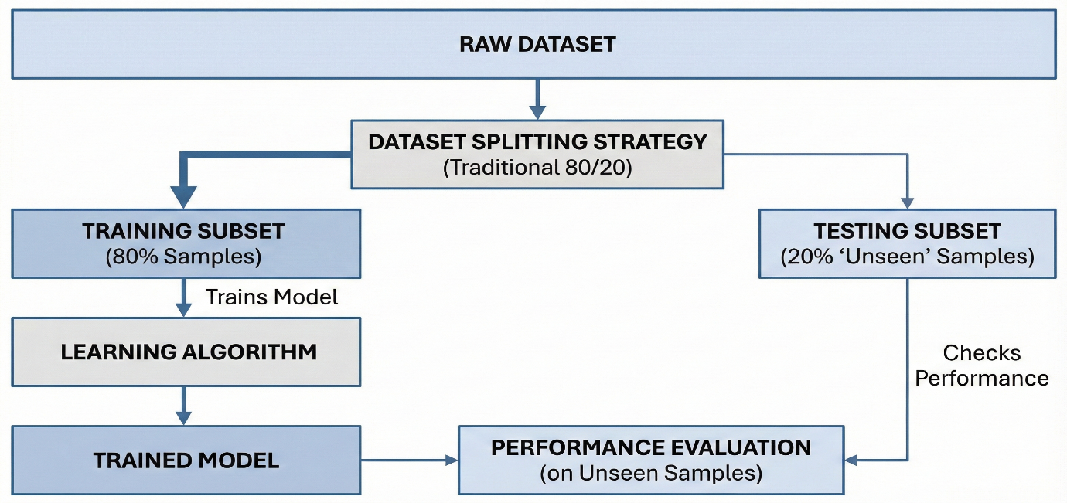
Figure 3: Dataset Splitting Strategy

3.3.4.3 Model Initialisation Strategy
The model development strategy involves initial machine learning model using a specific set of hyperparameters before it’s trained on the training dataset. These hyperparameters are the values that need to be initialised before training a model such as “number of estimators”, “maximum depth of tree”, “minimum leaf samples”, “number of jobs”, etc. These hyperparameters are spec described keeping in view the nature of applied models, i.e., ensemble and boosting. The model’s performance using these initial hyperparameters determines whether hyperparameter tuning is needed.

3.3.4.4 Model Fitting Stage
This stage will come directly after the initialisation of models and the model initialized with selected hyperparameters will be fit on the training dataset. The training of a model on the dataset may respective training times based on dataset’s nature (i.e., ~100,000 samples), and the performance of model will be tested.
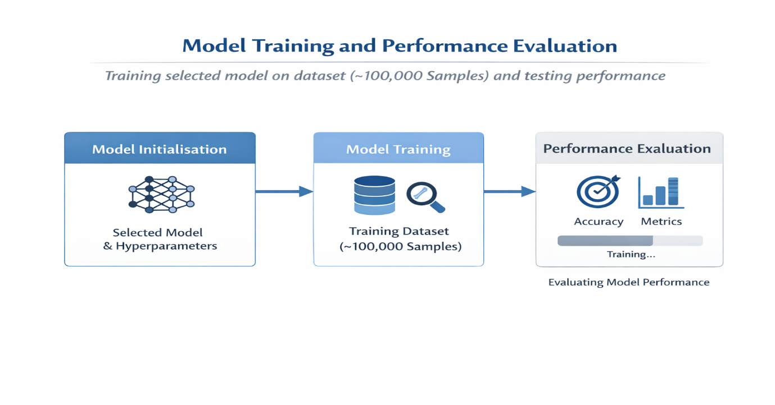
Figure 4: Stage of Model Fitting & Evaluation

3.3.4.5 Model Evaluation Stage
After successful fitting of models on the training dataset, the performance of model will be tested on unseen samples to check how well the model has learned feature representations from the training data. Based on dataset’s nature (i.e., classification), relevant evaluation methods will be used for evaluation, such as accuracy, precision, recall, f1 score and confusion matrix. The additional metrics along with accuracy are used since accuracy cannot provide a complete information of the performance of a model on individual classes of dataset.
Accuracy
This metric provides an “average result” of correct predictions on the unseen samples, given as:
$Accuracy=\frac{TP+TN}{TP+TN+FP+FN}$ (1)

Precision
Referred to as “proportion of predicted positives”, this metric shows the correct results of a model on positive dataset classes, given as:
$Precision=\frac{TP}{TP+FP}$ (2)
Recall
Also called as a “false positive rate” or “sensitivity”, this metric provides a value of how many predicted positive samples were “actually” positive.
$Recall=\frac{TP}{TP+FN}$ (3)
F1 Score
Used as a metric to balance the scores of “precision” and “recall”, this metric provides a harmonic mean of these metrics:
$F_{1}=\frac{2⋅Precision⋅Recall}{Precision+Recall}$ (4)
Confusion Matrix
This is an “NxN” matrix that provides a visual analysis of model’s performance on all classes. The dimensions of confusion matrix depend on the number of classes in the dataset, i.e., given 3 dataset classes, the dimensions of a confusion matrix will be “3x3”.
3.3.4.6 Application of Explainable AI
After a successful fitting of machine learning borders on the dataset and getting the desired results, this research provides a normal framework to provide a strategy to for making a trigger for tar pits. Approaches such as future importance will be used to analyze the highly important features based on model’s result, and a strategy will be formulated to underline tar pit behavioural signatures and detection triggers.

3.4 Selection Method Machine Learning Models
The selection criteria of machine learning models were taken in accordance with the nature and the size of the dataset, comprising of ~100,000 samples and dozens of features. Research indicates that ensemble and boosting based algorithms have the capacity to deliver optimised and reliable results especially on large scale datasets. These models have also the capacity of explaining the predictions approaches such as feature importance, which can be effectively used for making real-time deployments and effective insights from models.
Keeping in consideration the above scenario, this research uses 5 algorithms (1 ensemble, 4 boosting) as listed below:
- Random Forest Classifier
- XGBoost Classifier
- Light GBM Model
- AdaBoost Classifier
- Gradient Boosting Classifier

3.4.1 Random Forest Classifier
A Random Forest is an ensemble of multiple decision trees. Each tree is trained on a bootstrap sample of the data and at each split only a random subset of features is considered. The final prediction is obtained by majority vote from all trees. This reduces variance and overfitting compared with a single decision tree.
Key Mathematical Formulation
Each tree $h_{b}(x)$gives a class prediction. The Random Forest classifier predicts
$\hat{y}=mode⁡\{h_{1}(x),h_{2}(x),…,h_{B}(x)\}$
For binary classification, the probability estimate can be written as
$\hat{p}(y=1∣x)=\frac{1}{B}\sum_{b=1}^{B}{}I\left(h_{b}(x)=1\right)$
where $B$ is the number of trees and $I(⋅)$is the indicator function.

3.4.2 XGBoost Classifier
XGBoost is a gradient boosting method that builds trees sequentially. Each new tree is trained to correct the errors of the previous ensemble. It uses second order optimisation, shrinkage, regularisation and handling of missing values to improve performance and control overfitting.

Objective function
$L=\sum_{i=1}^{n}{}l\left({\hat{y}}_{i}\right)+\sum_{k=1}^{K}{}Ω(f_{k})$
with regularisation term
$Ω(f)=γT+\frac{1}{2}λ\sum_{j=1}^{T}{}w_{j}^{2}$
Second order Taylor expansion of the loss:
$L^{\left(t\right)}≈\sum_{i=1}^{n}{}\left[l\left({\hat{y}}_{i}^{\left(1\right)}\right)+g_{i}f_{t}(x_{i})+\frac{1}{2}h_{i}f_{t}^{2}(x_{i})\right]+Ω(f_{t})$

3.4.3 LightGBM Model
LightGBM is a gradient boosting framework based on decision trees that grows trees leaf-wise rather than level-wise. It uses histogram-based splitting and feature bundling to handle large datasets efficiently while keeping good accuracy.
Leaf-wise growth principle
LightGBM selects the leaf with maximum loss reduction
$Best leaf=arg⁡{max⁡}_{l}ΔL_{l}$

3.4.4 AdaBoost Classifier
AdaBoost combines many weak learners, often decision stumps. Misclassified samples get higher weights so later learners focus on harder cases. The final model is a weighted vote of all weak classifiers.
Weight update rule
Initial weights:
$w_{i}^{\left(1\right)}=\frac{1}{n}$
At iteration $t$:
$ϵ_{t}=\sum_{i=1}^{n}{}w_{i}^{\left(t\right)}I\left(h_{t}(x_{i})≠y_{i}\right)α_{t}=\frac{1}{2}ln⁡\left(\frac{1-ϵ_{t}}{ϵ_{t}}\right)$

3.4.5 Gradient Boosting Classifier
Description
Gradient Boosting builds models sequentially. Each new model is trained to fit the negative gradient of the loss function with respect to the current predictions. It is flexible because different differentiable loss functions can be used.
Additive model
$F_{0}(x)=arg⁡{min⁡}_{c}\sum_{i=1}^{n}{}l(y_{i},c)$
At iteration $m$:
$r_{im}=-{\left[\frac{∂l(y_{i},F(x_{i}))}{∂F(x_{i})}\right]}_{F=F_{m-1}}$

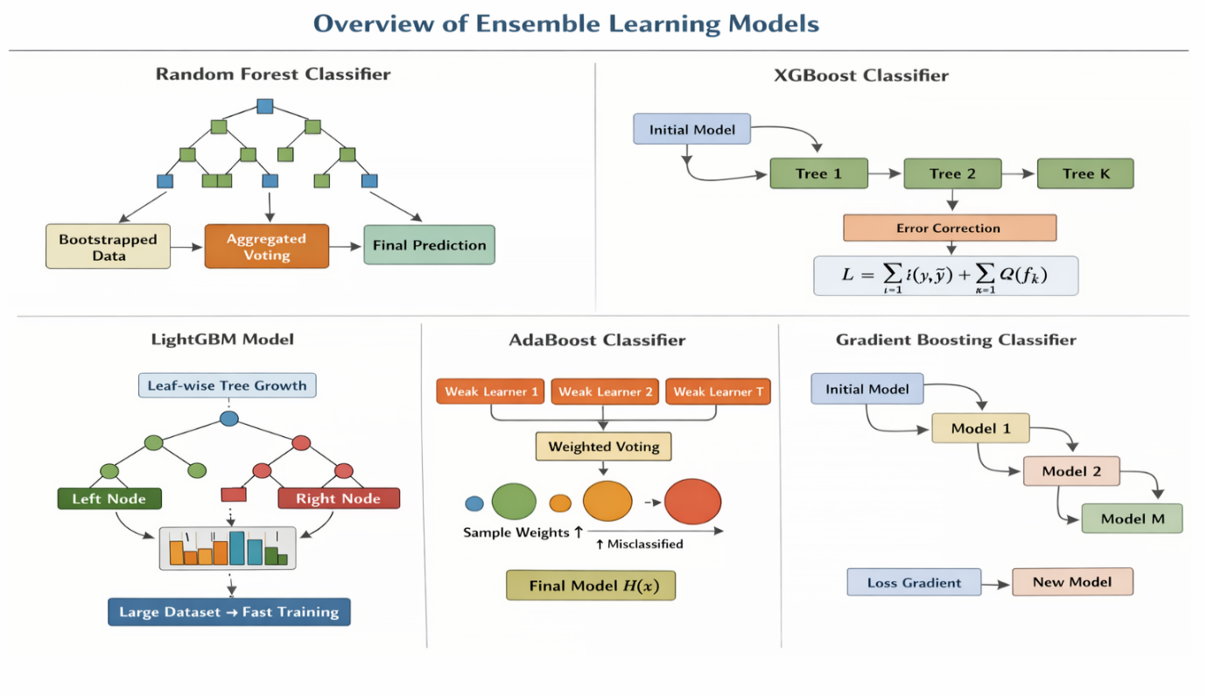
Figure 5: Visual Analysis of Applied ML Models

3.5 Selection of Dataset

3.5.1 Brief Description
This research uses “CTU-13” dataset as a baseline for making classification models, aimed at classifying human and bots via “botnet classification”. This data set comprises of ~100,000 samples and 59 features including a target feature. Originally the data set is accessed with two separate files comprising of “malicious traffic” and “benign traffic”, which was merged into a single file for computation.

3.5.2 Relevancy of Dataset & Justification
The CTU-13 dataset provides a robust empirical foundation for studying the “AI Crawler Tar Pits” phenomenon, as it contains thirteen labelled scenarios of realistic botnet, normal, and background network traffic captured at the “Czech Technical University”. Its heterogeneous composition, high dimensionality, and pronounced class imbalance replicate the complexity and noise of operational networks, making it ideal for analysing how AI models become trapped in local decision regions or overfit to misleading artefacts. Each scenario represents distinct botnet behaviours, enabling evaluation of model adaptability against diverse automated threats. Widely used in intrusion-detection research, CTU-13 offers benchmark comparability and methodological transparency. Its realism, diversity, and established reputation make it a suitable dataset for examining AI robustness, failure dynamics, and recovery in adversarial or unstable learning environments.

3.6 Programming Language Selection
For programming machine learning algorithms, “Python” is selected as a tool due to its extensive set of three different libraries and functions that can be used for machine learning. The following table list the libraries of Python that are used for development:

Table 3: Selection of Python Libraries
Library of Python | Usage
NumPy | Numerical python, used for mathematical tasks
Pandas | Data processing library, used for loading and preprocessing dataset
Matplotlib, Seaborn | Plotting utilities of Python, used for data analysis and plotting
Scikit-Learn | Machine learning in Python
XGBoost | Used for applying XGBoost model
LGBM | Used for fitting Light GBM Model
Adaboost | For accessing adaptive boosting (AdaBoost) model

3.7 Conclusion
Attaining high-quality results from machine learning requires an optimised, effective methodology to be applied. This chapter has a detailed methodological workflow of the application of learning algorithms for the classification of botnets and suggests a strategy to trigger a tarpit. Through an application of this applied methodology, this research will not only make effective classifications but will also contribute to initialising a framework that can be used as a method to trigger a tar pit for web crawlers.

Chapter 4 – Analysis & Development of Model

4.1 Introduction of Chapter
The current chapter will be entirely on defining a complete walkthrough of the development of machine learning algorithms on the dataset using the methodological flow as discussed in the previous chapter. The developmental procedure will be described in a step-by-step methodology using relevant coding screenshots and a description of the code mentioned in the screenshot. Taking ways from the previous chapter, the sequence of this chapter is given as:
- Dataset Loading
- Analysis on Dataset
- Dataset Preprocessing
- Selection of “X” and “Y”
- Dataset Splitting
- ML Model Initialisation
- Model Fitting for ML
- Evaluation of Machine Learning Methods (Discussed in Chapter 5)
- Comparative Analysis of Models (Chapter 5)
- Analysis & Visualisation of Tar Pit Strategy (Chapter 5)

4.2 Developmental Workflow of Machine Learning
This section will be entirely focused on the workflow of development using a step-by-step procedure, starting from “importing of necessary packages”.

4.2.1 Importing Python Packages
The first step in development was to import all crucial packages of Python and there relevant functions as mentioned in 3.6, given in the coding screenshot shown below:
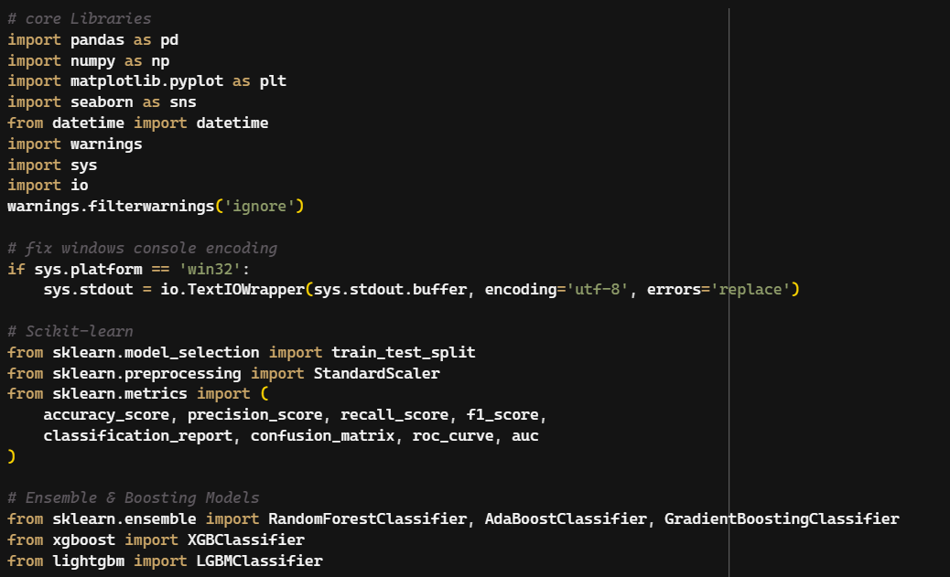
Figure 6: Importing Python Packages

4.2.2 Loading Dataset
Beginning the workflow, the first comprised of loading the dataset into memory using a pe-defined function of Python. In “pandas” library of Python, it provides a function named “read_csv ()”, that takes input a dataset in CSV format and loads it into the environment. Originally the was in two separate CSV files named as “CTU13_Attack_Traffic.csv” and “CTU13_Normal_Traffic.csv”, comprising of “botnet” and “normal” data packets. After loading both files separately, another function in the library was used named “contact ()” that merged both files in a single file, thereby making a complete dataset containing binary labels.
The screenshot shown below mentions how this procedure was done using the code
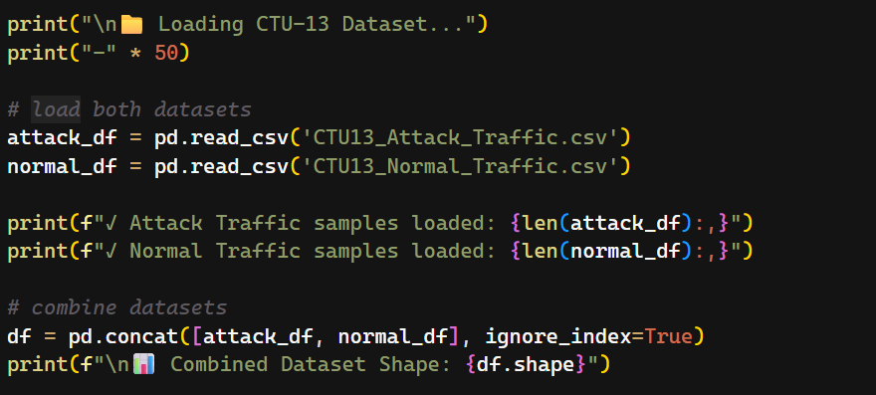
Figure 7: Dataset Loading in Workspace
After a successful loading of the dataset into memory, the combined data set contained a total of 92,212 samples with 59 features, as shown below:
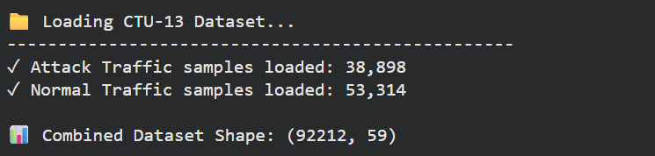
Figure 8: Dataset Samples

4.2.3 Understanding Dataset Structure
After successful loading of the dataset, the immediate step was to understand the structure of dataset using a function “.head()” from “pandas” library, which shows the details of first N features, as shown below:
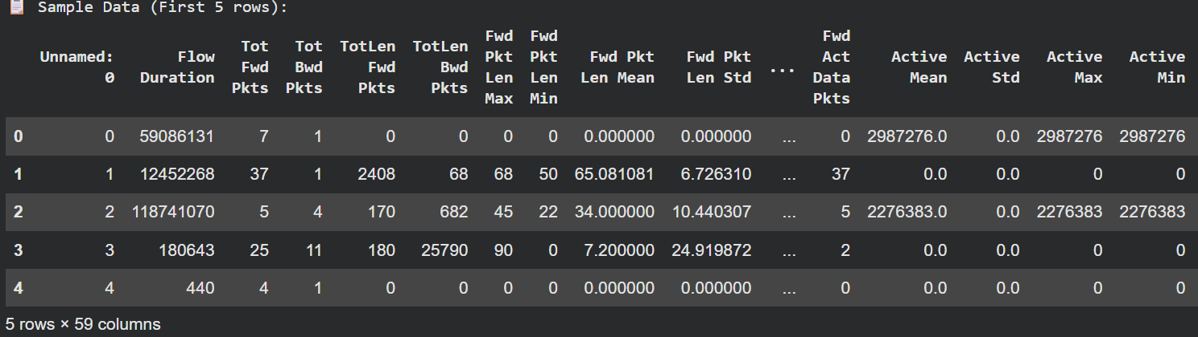
Figure 9: Dataset Structure (First 5 Rows)
As given from the screenshot above, the dataset contains information regarding data packets that indicate either a botnet or a normal behavior, such as “flow duration”, “total forward packets”, “total backward packets”, “forward packet length mean”, “active standard deviation”, etc. All these features can be used as an input to a learning algorithm for applying a classification task.

4.2.4 Exploratory Data Analysis (EDA)
Extensive data analysis was performed on the data set keeping in view of the dataset’s structure and behavior of numerical features. The process of data analysis is further subdivided into multiple stages, taking in consideration the type of analysis that is made.

4.2.4.1 Basic Information of Dataset
Starting the analytical procedure, the step was to basic information from the data as shown below:
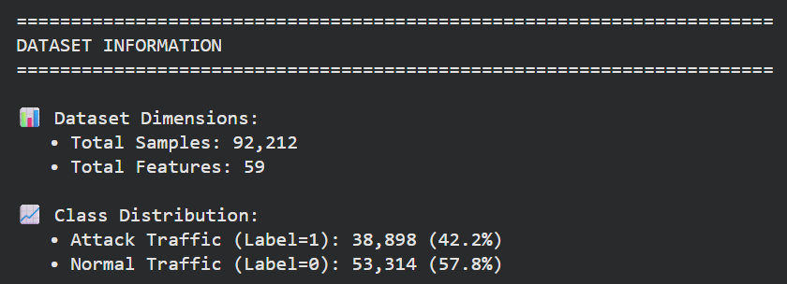
Figure 10: Basic Info from Data
Apart from a huge number of samples, the dataset shows a minor class imbalance, showing 57.8% samples belonging to positive class, while 42.2% samples indicate negative class. The class distribution analysis thoroughly discussed in the subsection.

4.2.4.2 Class Distribution Analysis
The class distribution analysis was performed using two plots, i.e., “pie chart” and “bar plot”, as shown below:
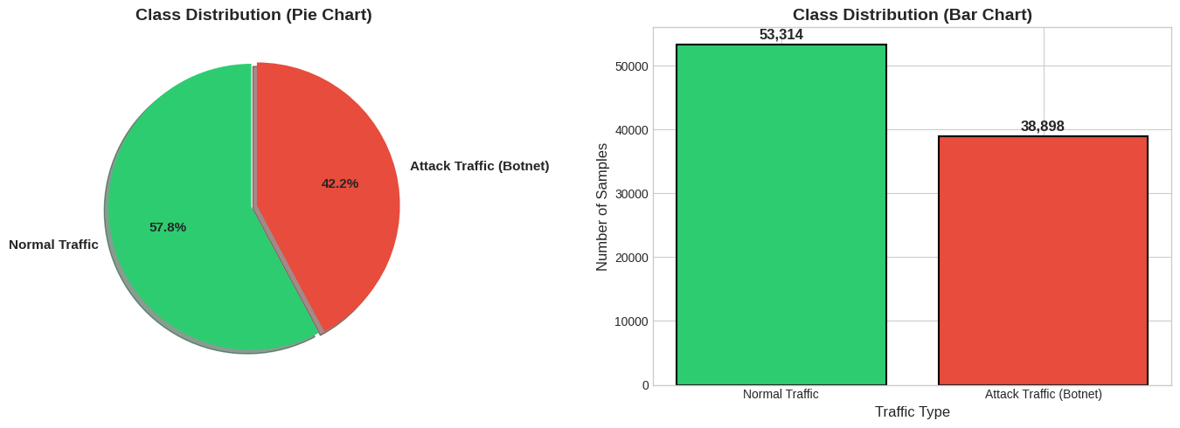
Figure 11: Class Distribution Analysis
- The figure presents the class distribution of network traffic samples in the CTU-13 dataset through both a pie chart and a bar chart, depicting the proportion and absolute frequency of Normal Traffic and Attack Traffic (Botnet).
- Normal traffic accounts for approximately 57.8% of the data, corresponding to 53,314 samples, while attack traffic represents around 42.2%, corresponding to 38,898 samples.
- This indicates a moderate class imbalance in which normal traffic is more prevalent, but attack instances remain substantial in volume.
- The distribution is representative of realistic network environments where benign traffic typically dominates, yet malicious activity is observable at a meaningful rate.
- Such a composition is advantageous for intrusion detection research because it provides sufficient samples from both classes to train and evaluate supervised learning models.
However, the imbalance implies that reliance solely on overall accuracy would be insufficient for performance assessment, and the use of complementary metrics, such as precision, recall, and F1-score, becomes necessary to capture the differing costs associated with misclassifying normal and botnet traffic. This research has also made use of additional metrics along with accuracy to justify the performance of models.

4.2.4.3 Feature Distribution Analysis
The following graph shows the feature distribution analysis of numerical features with respect to traffic class. The graph provides a healthy source of information which will be discussed in detail below the plot.

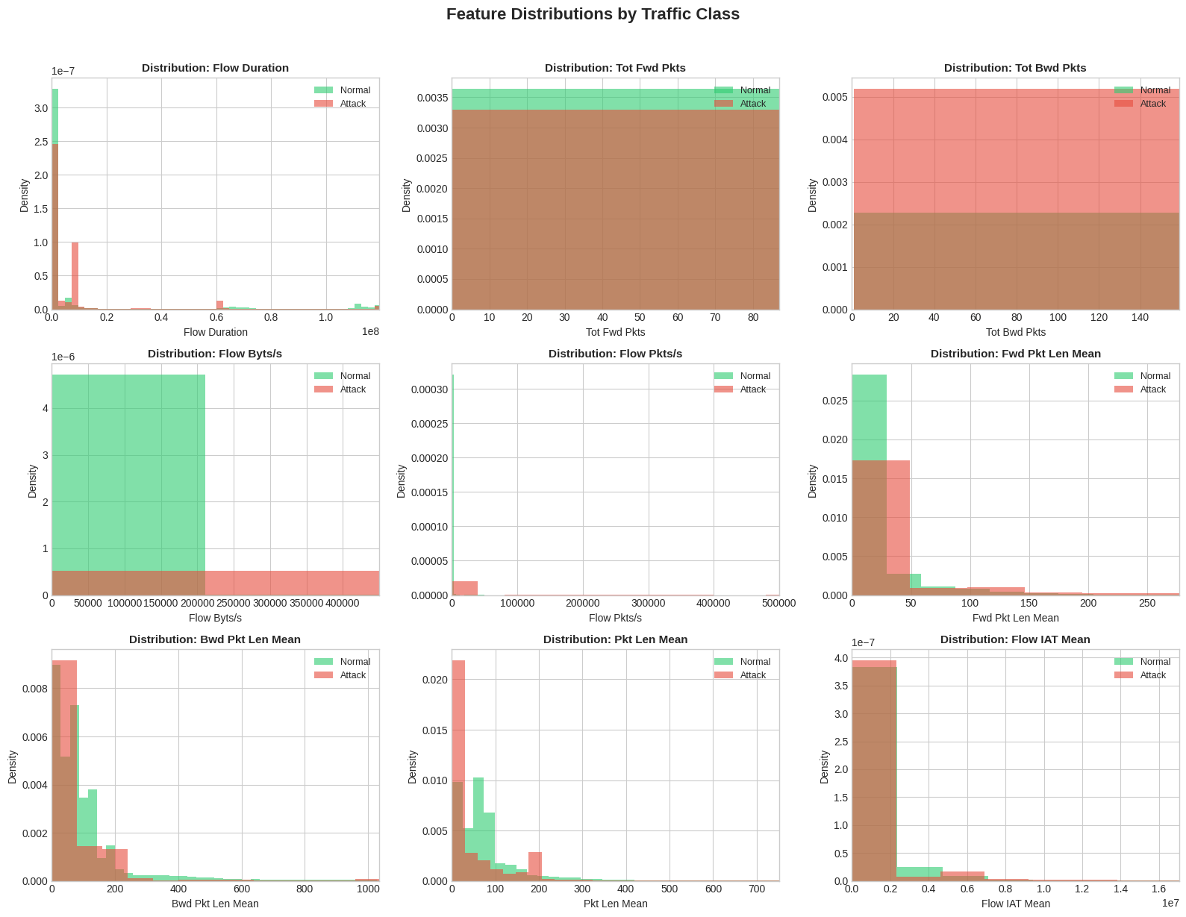
Figure 12: Feature Distribution Analysis
- The above figure shows empirical distributions of salient network flow data of normal and malicious traffic and hence explains interclass statistical differences
- Most of the attributes have high positive skew, and a large portion of observations lie at the lower magnitudes with a long tail stretching to the heavy intensity flows
- Flow duration shows greater variability with malicious traffic, showing the coexistence of both extremely short and otherwise unusually long flows as compared to the normal flow that is predominantly shorter
- Both total forward packets and total backward packets indicate a lot of overlap among the classes, but the malicious traffic has a higher density at the lower packet counts, which is, again, consistent with the nature of transmission of automated botnet activity
- Flow packets per second and flow bytes per second show heavier tails of malicious traffic, in which spurts of high activity are not so frequent as in benign flows
- Forward and backward packet length mean distributions indicate that malicious traffic often has smaller packet sizes on average, which is also in line with command-and-control traffic, but normal traffic has larger dispersion
- Packet length mean also proves that the separation between classes in the lower range is also present, and its discriminative quality is evidenced
- The flow inter-arrival time mean has significant dispersion on malicious flows, indicating that the timing aspect is not consistent with the normal traffic, which is more concentrated
In general, the distributions suggest that, although there is significant overlap between classes, a variety of features, especially rate-based and timing-related attributes, are useful to provide useful discriminative ability to differentiate between normal network activity and malicious behaviour in the CTU-13 data.

4.2.4.4 Analysis of Highly Correlated Features
Another crucial analysis that was performed was the analysis of highly correlated features, that helped in appropriate feature selection for predictor variables. Using predefined functions from the “pandas” library and computing the correlation our features with respect to the target variable, a list of 10 features was extracted that were highly correlated, as shown below:
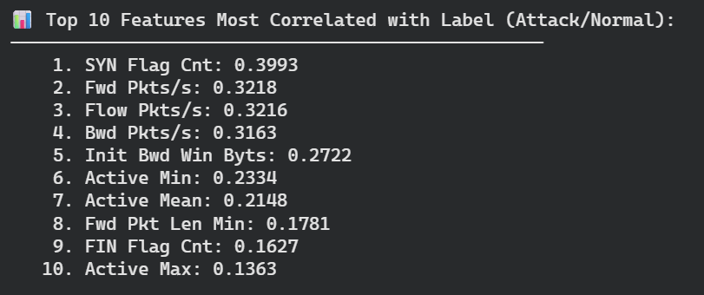
Figure 13: Highly Correlated Features
The ranked correlation results indicate that:
- The attack behaviour in the CTU-13 dataset is strongly associated with specific flow and flag-based characteristics rather than with generic traffic volume alone
- The highest correlation is observed for the “SYN flag count”, which suggests that malicious activity is closely related to abnormal connection initiation patterns, consistent with scanning or SYN flood behaviour
- The strong correlations of “forward packets per second”, “backward packets per second”, and “overall packet rate” imply that “traffic burstiness and transmission frequency” are key discriminative indicators between attack and normal flows
- Features related to “initial backward window bytes” and “active time statistics” (minimum, mean, and maximum) further indicate that temporal dynamics and TCP window behaviour differ substantially for malicious connections
- The presence of “minimum forward packet length” and “FIN flag count” among the top features highlights that “packet size irregularities” and “abnormal session termination activity” also contribute to distinguishing attacks from benign traffic

4.2.4.5 Using Analysis for Feature Selection
The preceding analyses provide an empirical basis for informed feature selection when developing machine learning models for botnet detection using the CTU-13 dataset. The feature distribution plots demonstrate that several variables exhibit clear differences in central tendency, spread, and skewness between normal and attack traffic, particularly rate-based features, packet length statistics, and timing-related metrics, which show observable class separation. The correlation analysis further reinforces this by identifying features such as “SYN flag count”, “packet rates”, “TCP window characteristics”, and “activity time statistics” as highly associated with the target label.
The combination of these results suggests that the features that incorporate connexion dynamic features, packet exchange rates, and protocol-level flag behaviour are probably the ones that would add the most to the model discriminative power. Features with a statistically significant area of overlap between classes or insignificant association with the label can be deprioritised or eliminated to reduce the dimensionality and prevent overfitting on the other hand. This analysis, therefore, can be explicitly used in the building of more parsimonious and effective sets of features that result in better model performance, computational efficiency and interpretability.

4.2.5 Dataset Preprocessing
After successful implementation of data analysis, data preprocessing was applied on the dataset to remove any redundant or missing values and provide a clean output to learning algorithms. This stage comprised of following sub-stages:
- Checking & Removing Unnecessary Columns
- Checking Infinite Values
- Visual Analysis of Missing Values

4.2.5.1 Checking & Removing Unnecessary Columns
The first step in data preprocessing was to check for any redundant column that could be removed from the feature set, as these columns can limit model’s performance. The following screenshot describes how this was achieved in code:
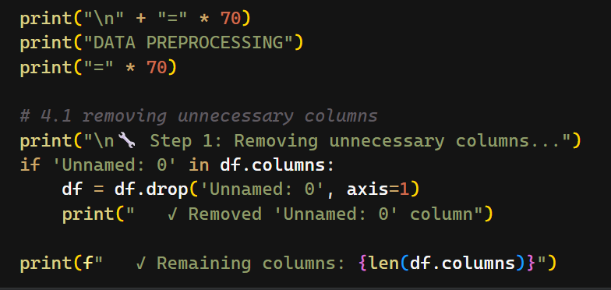
Figure 14: Removing Unnecessary Columns

After executing the code above, one unnecessary column was removed from the dataset, as shown below:
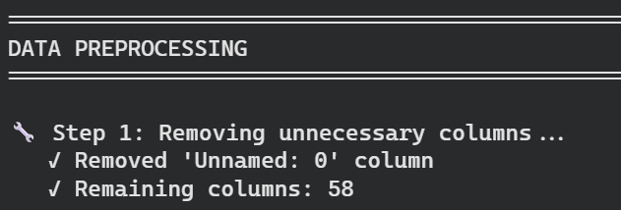
Figure 15: Removal of Unnecessary Column

4.2.5.2 Checking Infinite Values
There was a possibility that the dataset may contain features with infinite values, which also needed to be removed from the feature set. Therefore, a check was performed to check these values, as shown below. The code below first selects the numerical columns, then applies a check for infinite values using “np.isinf ()” function, then applies a sum of all those values to make a total of possible infinite values. It then also uses a decision structure to fill those values with maximum value of the column, if an infinite value is found.
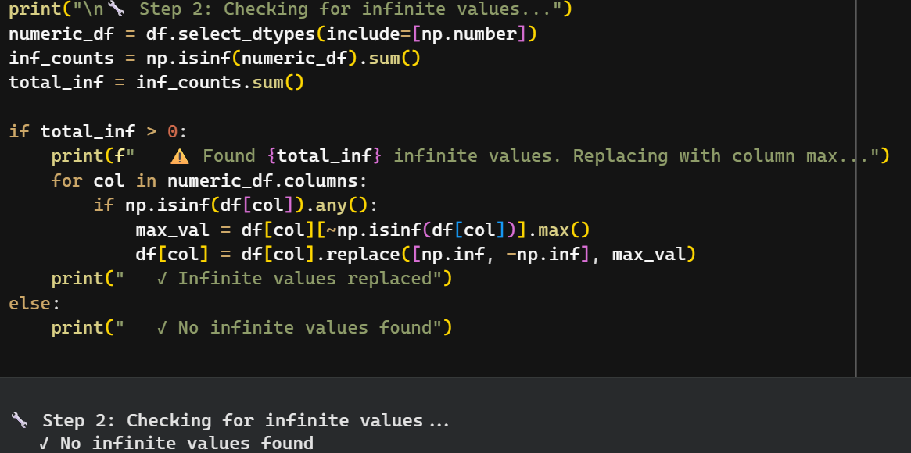
Figure 16: Checking Infinite Values
The output shows that there is no infinite value found in the dataset, meaning that all numerical values are placed within a range.

4.2.5.3 Missing Value Analysis in Dataset
The purpose of this analysis was to confirm if there was a missing, null or NaN value in the dataset, which could be filled with a relevant imputation approach. The following plot visualizes the distribution of missing values in all columns:
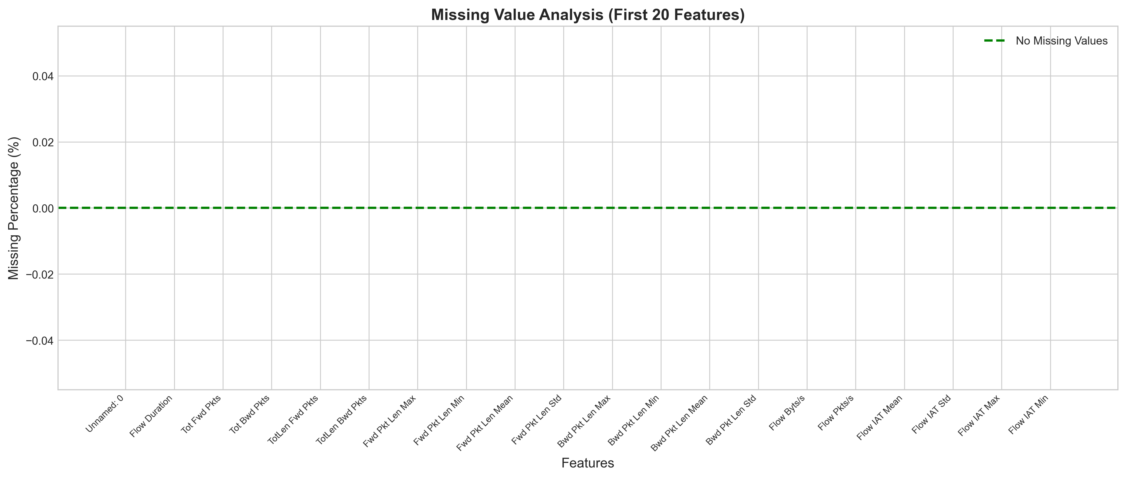
Figure 17: Missing Value Analysis
Based on the analysis of top features of the dataset, it can be given that:
- There is no missing or null value in the dataset, which could be imputed
- The dataset is clean, and features are ready to be passed to a learning algorithm for model fitting and classification
After implementing the stage of data preprocessing, the dataset was cleaned and made ready to be passed to a machine learning algorithm. During preprocessing, one unnecessary column was removed from the dataset, thus making use of 58 features in total.

4.2.6 Selection of “X” and “Y” Values
Taking in consideration the behavior of and correlation with the target value, all features except the “target” were selected as predictors, while one feature named “label” was set as target, indicating a binary value (0 for normal, 1 for botnet).
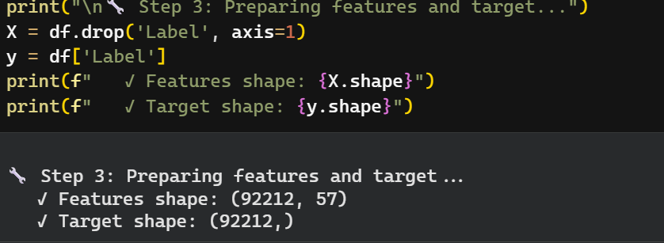
Figure 18: Selection of “X” & “Y” Values

4.2.7 Splitting Dataset into Train & Test
The dataset was split into 2 subsets, training and testing, with a ratio of 80:20, i.e., 80% of the dataset was taken for training, while rest was kept for testing purposes. This procedure was implemented using a function named “train test split ()” from “scikit-learn” library that takes input as X and Y values, the test ratio, and splits the original dataset into 2 subsets, as shown below:
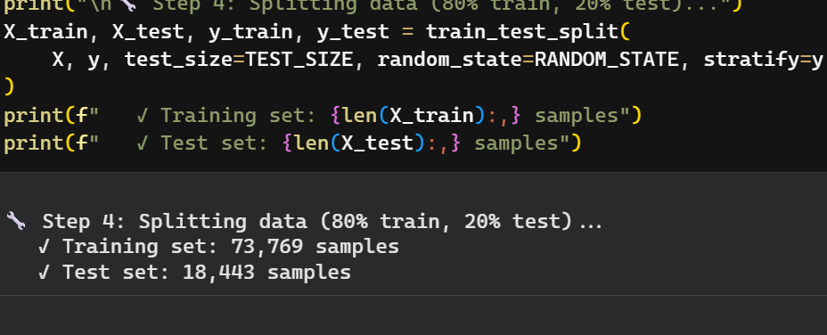
Figure 19: Dataset Splitting
After making a split of 80-20, there are 73,769 samples placed in the training set, while 18,443 samples are used to access the performance of models. In above code, another parameter named “stratify” is also used, ensuring that testing set gets equal sample distribution of both classes. The stratification towards the targets sample balances the performance of a model on all classes and provides an optimised output.

4.2.8 Scaling of Training & Testing Datasets
To address potential biases in the dataset and standardize feature values across varying scales, standard scaling was applied separately to the training and testing datasets. This approach—performed after splitting the data, thus preventing data leakage by ensuring independent scaling of each set.
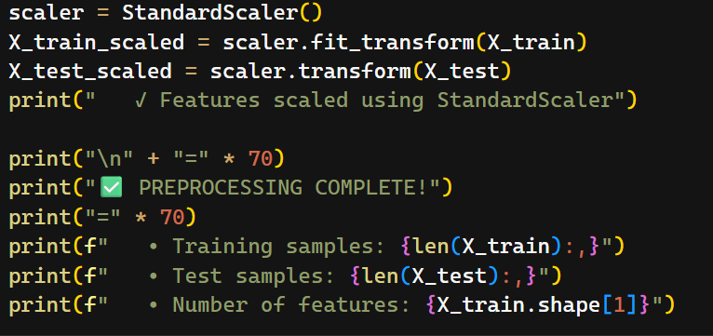
Figure 20: Feature Scaling on Train & Test
At this point, the procedure of dataset preprocessing is completed, and this dataset is ready to be passed to a machine learning algorithm. For ML models, the dataset comprises 57 predictor features and a target feature (attack type).

4.2.9 Initialising Machine Learning Models
At this implementation stage, the machine learning algorithms were initialised and fit on the training dataset. This stage comprises of the following steps:
- Initialising ML Algorithm Using Specified Hyperparameters
- Fitting ML Model to Training Dataset
- Making Predictions on Test Dataset
- Storing Results in a Variable
This chapter will discuss the initialisation and model fitting procedures of learning algorithms, while evaluation of these models will be discussed thoroughly in Chapter 5.

4.2.9.1 Hyperparameters of ML Models
Table 4: Hyperparameter Setting of ML Models
Model | Key Hyperparameters | Values
Random Forest Classifier | Number of trees (n_estimators) | 50
 | Maximum depth (max_depth) | 20
 | Minimum samples per leaf | 2
XGBoost Classifier | Number of trees (n_estimators) | 100
 | Maximum depth (max_depth) | 10
 | Learning rate | 0.1
Gradient Boosting Classifier | Number of boosting stages | 100
 | Maximum depth | 8
 | Learning rate | 0.1
AdaBoost Classifier | Number of estimators | 100
 | Learning rate | 0.5
LightGBM Classifier | Number of trees (n_estimators) | 100
 | Maximum depth | 10
 | Number of leaves | 31

4.2.9.2 Fitting Machine Learning Models
Using the hyperparameters mentioned in Table 4, all models were fit to the scaled training dataset for making final predictions, as shown in following coding screenshots.
Fitting Random Forest Classifier
The “random forest classifier” was fit using the following code:
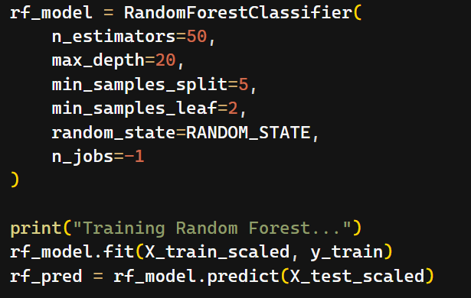
Figure 21: Fitting Random Forest
Fitting XGBoost Classifier
The “XGBoost classifier” was fit using the code, as shown in the following snapshot:
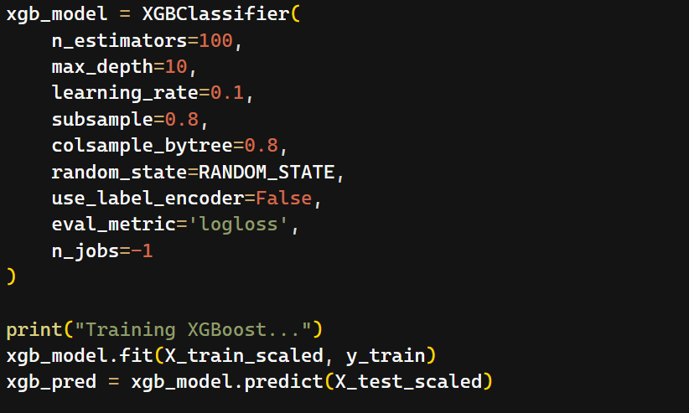
Figure 22: Fitting XGBoost Model

Fitting Light GBM Model
Following code shows the model fitting procedure of “Light GBM Model”:
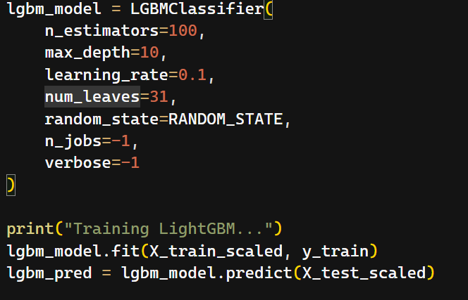
Figure 23: Fitting LGBM Model
Fitting AdaBoost Classifier
The following code shows how this model was fit to the training dataset:
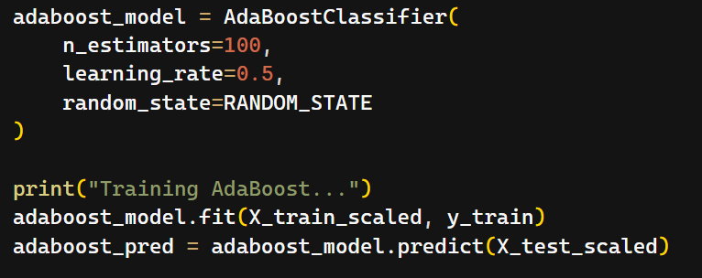
Figure 24: Fitting AdaBoost Model
Fitting Gradient Boosting Model
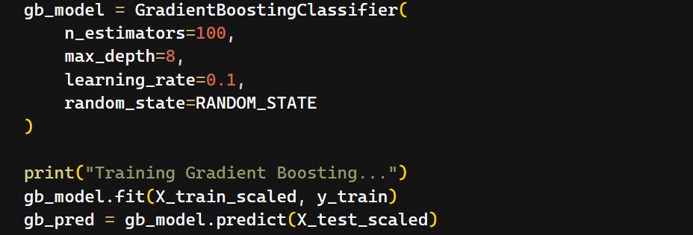
Figure 25: Fitting Gradient Boosting Model

4.3 Conclusion of Chapter
Till the end of Chapter 4, a complete walkthrough of the entire developmental process (till model fitting) is explained along with screenshots of code. This chapter has detailed each step in coding the machine learning algorithms, along with justifications for the chosen approaches and screenshots of the code. This process continues in the next chapter, which presents a detailed evaluation of the models and analysis of the results.

Chapter 5 – Results of Models

5.1 Chapter’s Introduction
The focus of this chapter on the evaluation of learning algorithms using the relevant evaluation methods, continuing the flow of previous chapter. The models will be evaluated based on all relevant methods such as accuracy, precision, recall, f1 and confusion matrix. Along with the providing the results of each model, this chapter will also discuss and novel strategy that can be used for injecting a mechanism for making a “tar pit” for web crawlers.
In this chapter, the results of models will be elaborated as:
- Overall Results of Each Model
  - Accuracy
  - Precision
  - Recall
  - F1 Score
- Comparative Analysis of Models’ Results
  - Bar Chart Analysis
  - Confusion Matrices of Models
  - Tabular Analysis of Models’ Results
- Mapping Research to Tar Pits (Mechanism for Tar Pits)

5.2 Overall Results of All Models
Overall, the results of all models were exceptional on the testing dataset, with each model attaining an accuracy of 99.5% with balanced results on precision, recall, and F1 score. This highlights the efficient computational efficiency and strength of boosting algorithms to compute on large scale datasets. The results of each model are discussed below:

5.2.1 Results of “Random Forest”
Providing exceptional score on test dataset, this model provided an accuracy of 99.77% on testing dataset, as shown below:
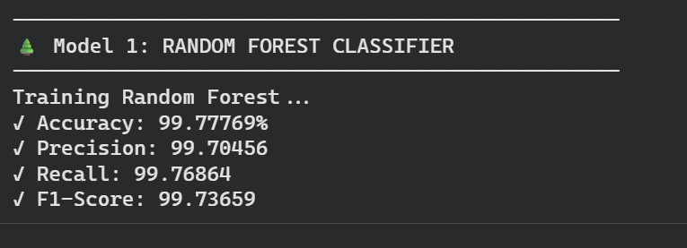
Figure 26: Results of Random Forest Model

5.2.2 Results of “XGBoost Classifier”
Moving parallel in providing the results with the previous model, this model also yield an extraordinary accuracy of 99.8% on testing samples, indicating strength in dealing with datasets as shown below:
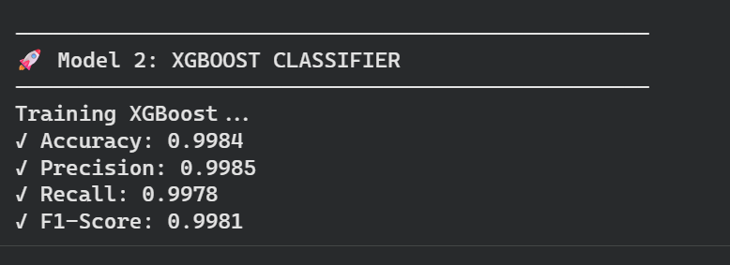
Figure 27: Results of XGBoost Model

5.2.3 Results of “Gradient Boosting Classifier”
The performance gradient boosting model was consistent with previous two models, yielding a score of 99% on accuracy. Though this model took the highest time to train on the dataset, the results of this model were comparable with random forest and XGBoost.
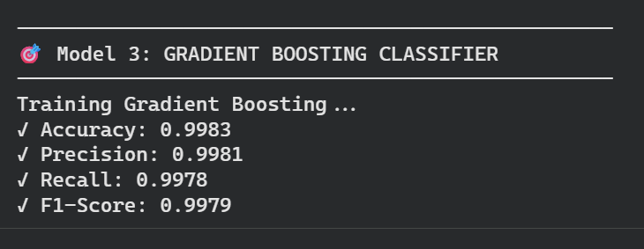
Figure 28: Results of Gradient Boosting Model

5.2.4 Results of “AdaBoost Classifier”
The performance of this model was notable on the testing samples with a score of 98.3%, though this model yielded the least accuracy score on testing data:
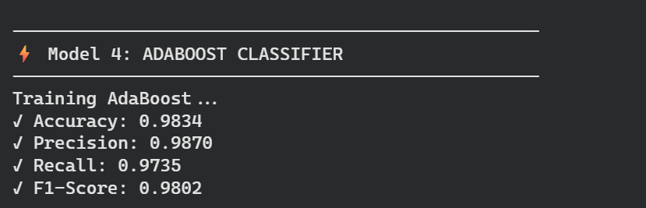
Figure 29: Results of AdaBoost Classifier

5.2.5 Results of “Light GBM Classifier”
Taking the least time to train on the dataset, the performance of this was above 99% on testing samples:
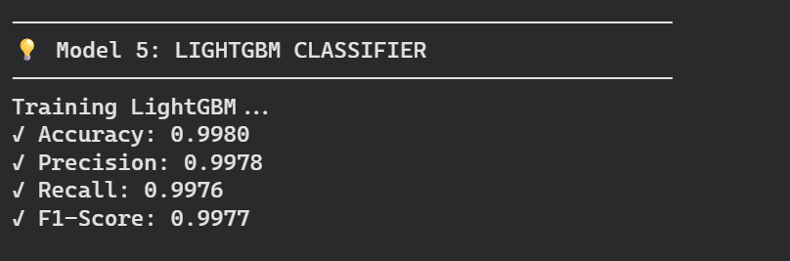
Figure 30: Results of LGBM Model

5.3 Comparative Analysis of Models’ Results
The current section is focused on making a detailed comparative analysis of models using accuracy bar charts confusion matrices and tabular analysis.

5.3.1 Bar Chart Analysis
The following figure visualizes a bar chart, comparing the accuracies of models on testing dataset:
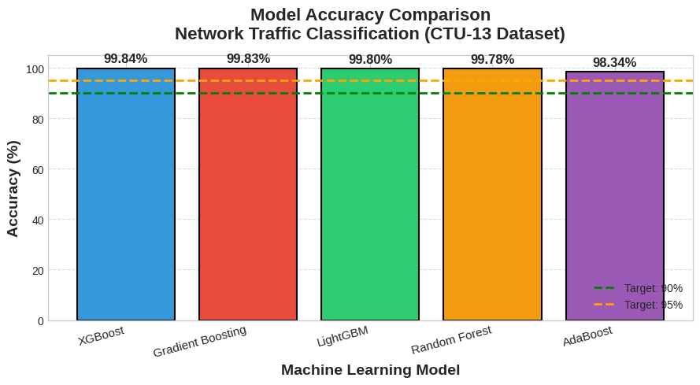
- The figure compares the general classification accuracy of the five assessed ensemble learning models utilised on the CTU-13 dataset. Each of the models exceeds the preset performance threshold of 90-95%, and hence, it shows a strong predictive performance on the classification of network traffic
- Under the XGBoost, the highest accuracy is seen at 99.84%, which is quickly followed by free gradient boosting at 99.83%, LightGBM at 99.80% and the last random forest at 99.78%
- The lowest accuracy of the group is achieved with AdaBoost (98.34%), but it is still competitive in comparison with the target benchmarks
- The marginal differences that are evident between the best four models indicate that both the gradient-boosting and bagging methods can replicate the underlying traffic trends, although the former has a slight lead
- Generally, the findings support the fact that advanced ensemble algorithms, specifically XGBoost, can provide high-quality performance in discriminating between normal and attack traffic among the CTU-13 dataset.

5.3.2 Confusion Matrices of Models
For making a more interactive visualization of the performance of models on both classes, confusion matrices were used, as shown below:
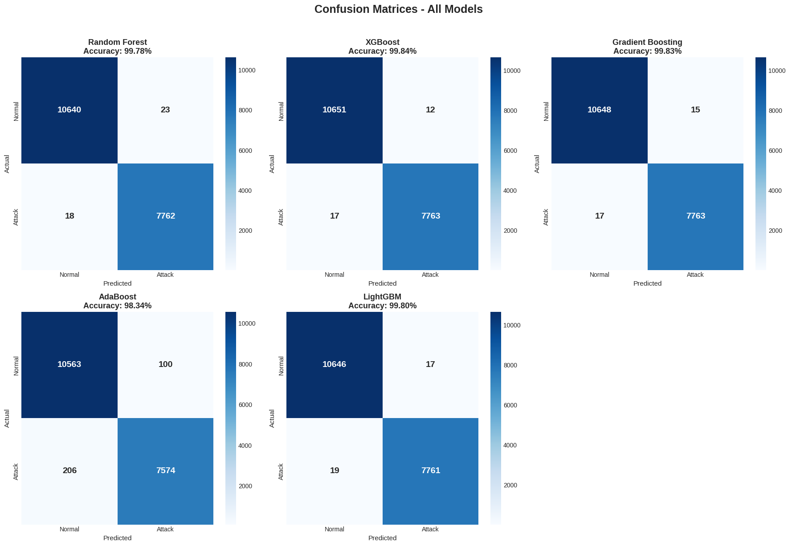
Figure 31: Confusion Matrices of Models

Analysis of Confusion Matrices
- The confusion matrices in the figure demonstrate the classification performance of the 5 ensemble models in the CTU13 dataset in normal and attack traffic classes. In general, all the models are very accurate, with XGBoost having the highest accuracy (99.84%), then comes Gradient Boosting, LightGBM and Random Forest, and lastly is AdaBoost, which only has 98.34%.
- The Random Forest model wrongly identifies just 23 normal flows as attacks and identifies 18 attacks as normal and thus shows a balanced behaviour in both categories.
- XGBoost has the lowest total cases of misclassifications, with 12 false positives and 17 false negatives, which exhibit strong discriminatory power on benign and malicious traffic.
- Similar behaviour is observed in Gradient Boosting and LightGBM, both of which have proportionately small false positive and false negative values, and this highlights the fact that boosting-based techniques are adequate at identifying subtle differences among classes.
- On the contrary, AdaBoost has a much larger error rate and many more false negatives (attack flows misclassified as normal), which is not good in an intrusion detection setting where undetected attacks are dangerous to operations.
- Such findings suggest that more sophisticated gradient-boosting models, in particular, XGBoost and LightGBM, have better detection properties and a low error rate of misclassification, but with more complex architecture, Random Forest is also competitive.
Therefore, the results help verify the appropriateness of boosting-based ensemble models in solving issues related to network intrusion detection where maximising sensitivity to malicious traffic is necessary.

5.3.3 Tabular Analysis of Results
Table 5: Performance Comparison of Machine Learning Models on CTU-13 Dataset
Model | Accuracy (%) | Precision (%) | Recall (%) | F1-score (%)
XGBoost | 99.84 | 99.85 | 99.78 | 99.81
Gradient Boosting | 99.83 | 99.81 | 99.78 | 99.79
LightGBM | 99.80 | 99.78 | 99.76 | 99.77
Random Forest | 99.78 | 99.70 | 99.77 | 99.74
AdaBoost | 98.34 | 98.70 | 97.35 | 98.02

5.3.4 Reasoning of High Accuracy on Dataset
The high accuracy achieved by all evaluated models can be attributed to a combination of dataset characteristics, intentional feature engineering, and advanced ensemble learning algorithms. The CTU-13 dataset exhibits strong behavioural differences between normal and malicious traffic, captured through distinct distributions of salient features such as packet rates, flow durations, packet-length distributions, and inter-arrival times. The correlation analysis also revealed that the protocol-level features, such as the numbers of SYN flags, FIN flags, active-time features, and packet-rate features, have a strong correlation with the label of the attack, and thus well-separated decision limits can be obtained by the classifiers.
Furthermore, the feature-selection process placed emphasis on discriminative features whilst reducing irrelevant variance, thereby reducing overfitting and increasing generalisation. Ensemble methods such as XGBoost, Gradient Boosting, LightGBM, and Random Forest are especially effective at nonlinear relationships and any nonlinear interaction of traffic traits, hence improving the predictive power. Confusion matrices indicate that the rate of both false positives and false negatives is extremely low, which proves the idea that the models learn and do not merely memorise training data, as they reflect underlying traffic tendencies. All these observations together support the large accuracy achieved and emphasise the fact that the performance can be explained by methodological rigour and informative data properties, but not by stochasticity and overfitting.

5.4 Security Interpretation of Results
From a security operations perspective, the high classification performance achieved across all evaluated models indicates that malicious automated traffic can be reliably identified with a very low false negative rate. This is particularly important in defending system availability, as undetected malicious crawlers may continuously consume resources and degrade service performance over time.
The balanced precision and recall values observed across models also suggest that the detection approach is suitable for deployment in security-sensitive environments where excessive false positives could disrupt legitimate users. By enabling accurate discrimination between benign and malicious traffic, the proposed approach supports proactive security enforcement rather than reactive incident response.
These results show that machine learning models can function not only as stand-alone classifiers but also as an efficient decision-making element inside a more comprehensive defensive security architecture.

5.5 Research Novelty Mapping Results to “Tar Pits”
This section provides visualizations and analysis that directly map the network traffic classification results to the “AI Crawler Tar Pits” research topic, demonstrating how the botnet detection model can be applied to detect and trap malicious AI crawlers.

5.5.1 Behavioral Signature Analysis: Botnets vs AI Crawlers
The behavioural analysis presented in Figure 32 clearly shows distinct activity signatures between legitimate crawlers and botnet-driven malicious crawlers across key indicators such as request frequency, session duration, data transfer rate, and server response behaviour. These differences indicate that botnets exhibit automated, burst-like, and irregular interaction patterns which are highly suitable for trigger-based “Tar Pit” activation.
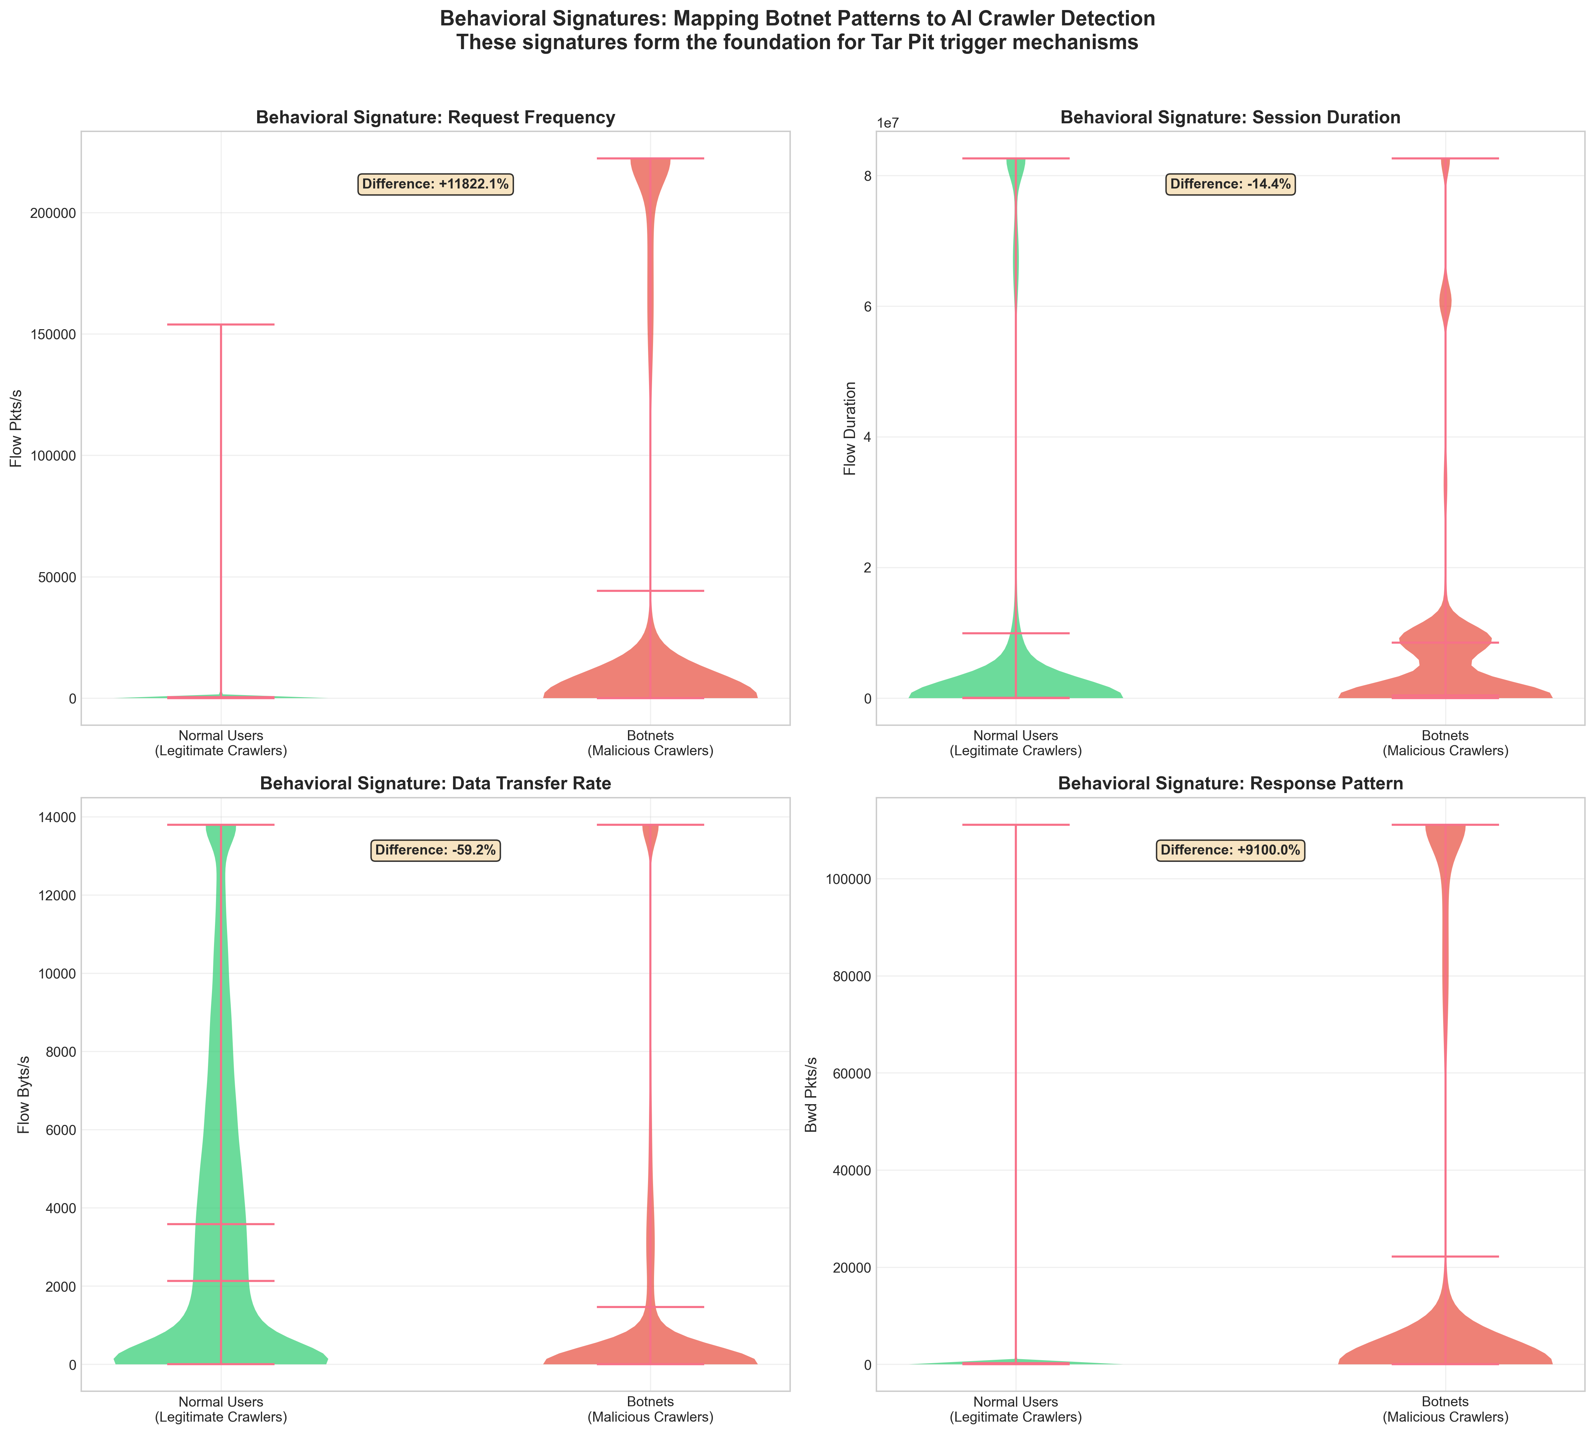
Figure 32: Tar Pit Behavioural Signatures

5.5.2 Tar Pit Detection Triggers
Figure 33 illustrates the aggregated feature importance categories, indicating the most influential triggers for detection are timing anomalies, traffic volume irregularities, packet behaviour variations, and abnormal protocol flag usage. These categories align directly with the practical design of “Tar Pit mechanisms,” which rely on behavioural thresholds to slow, trap, or misdirect malicious crawlers.
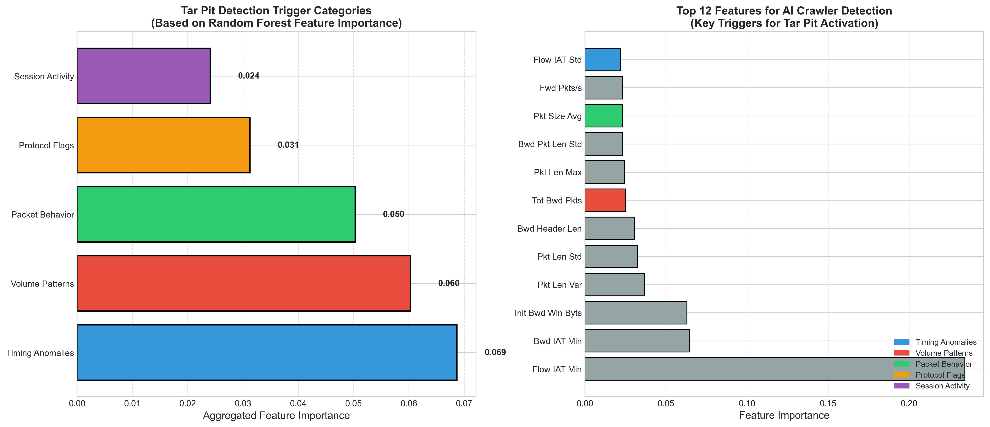
Figure 33: Detection Triggers for Tar Pits

5.5.3 Tar Pit Response Strategy
The confidence-based structure used in Figure 34 is one that converts probabilities of model prediction to graded Tar Pit responses. The system matches one or another part of classification certainty with a continuum of defensive measures, ranging from crude surveillance to outright entrapment. In turn, this strategy will allow selective activation of tar pits only in the case of increased confidence in malicious AI crawling behaviour, which will reduce the amount of interference by legitimate users and, at the same time, increase the effectiveness of targeted protection against aggressive automation.
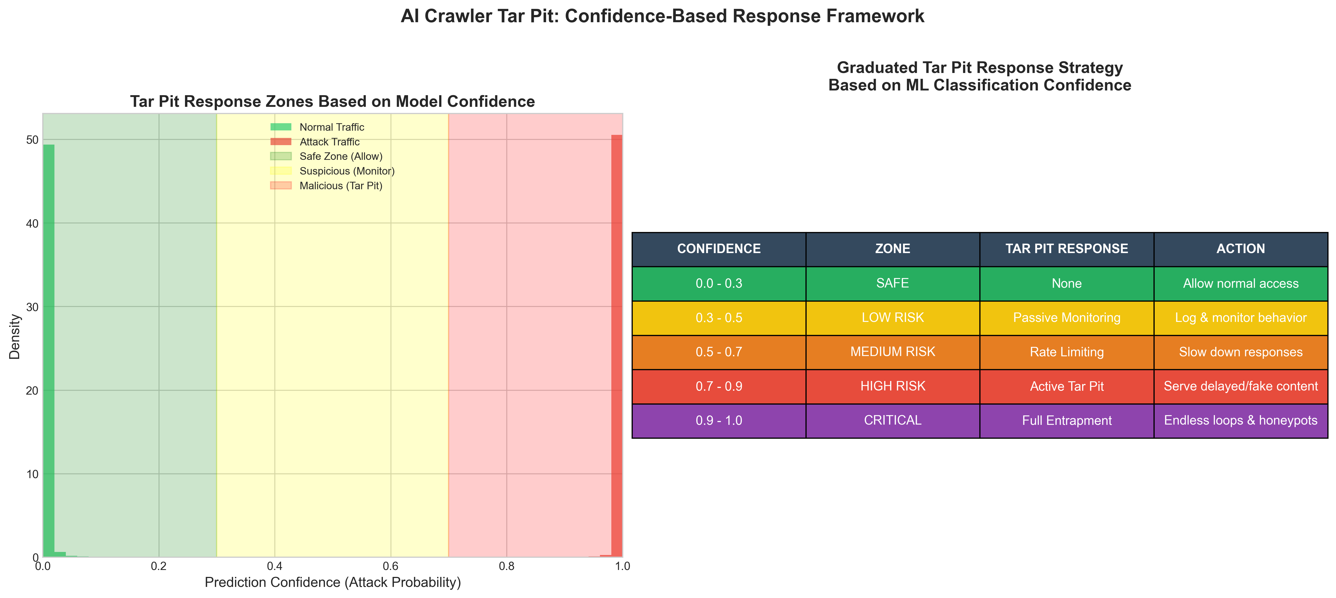
Figure 34: Confidence-Based Response Framework

5.6 Conclusion
This chapter was focused on elaborating the details related to models’ results, the justification behind achieving high accuracies on test dataset, and a response-based framework to trigger “tar pits” for AI web crawlers. Apart from attaining high results on the dataset, this research has also provided a novel framework to integrate the results “potentially” to trap web crawlers.

Chapter 6 – Conclusion & Recommendations

6.1 Conclusion
This research was focused to examine how malicious AI-driven crawlers could be identified using “AI Crawler Tar Pits”. Using the CTU-13 data as the sample of adversarial activity of automated networks, it was possible to develop a robust analytical pipeline, including data preprocessing, exploratory data analysis, model development, and interpretability assessment. The results indicate that the ensemble learning methods provide a high accuracy in distinguishing botnet and normal traffic, with all models exceeding the accuracy of 98% and some of them exceeding 99.7%. Importantly, the predictive performance is high and is supported by substantive behavioural dissimilarity among classes, which, in turn, curbs the fear of chance performance or overfitting.
The study also illustrates that malicious crawlers have unique signatures, such as high request rates, abnormal timing of sessions, high packet rates and peculiar patterns of protocol flags. The features were verified by the feature-distribution analysis, by the evaluation of the correlations, and by the ranking of the feature importance calculated using the models. The main contribution is that they should be translated into a response framework based on confidence that consists of tar, where the confidence of classification determines how defensive actions should be stratified. This framework enables the selective slowdown, deceit or isolation of malicious agents but at the same time supports continuous access by authorised users.
Putting in a nutshell, the study provides an evidence that the operational support of AI Crawler Tar Pits can be supported by machine-learning-based botnet detection. It shows that the outputs of detection can be operationalised into response action plans and no longer remain in the form of mere classification outcomes. Subsequently, this piece of work offers theoretical novelty and practical worth to safeguard automated data ingestion assets.

6.2 Project Development Process & Reflection
The project's original goal was to look at the long-term behavioral deterioration of malicious crawlers under repeated ingesting settings as well as detection accuracy. A staged development strategy was used, starting with baseline model training and dataset preparation, then moving on to the conceptual design of an AI-driven tar pit framework and a comparative analysis of several algorithms.
The final scope of the work was determined by a number of restrictions during development. It was not possible to change the dataset or carry out lengthy streaming tests due to resubmission time constraints. Consequently, the emphasis switched to increasing reflective analysis in accordance with the module learning aims, strengthening conceptual clarity, and aligning machine learning outputs with security objectives.

Notwithstanding these drawbacks, the research effectively illustrates how machine learning may be included into an operational security control as opposed to continuing to be a strictly analytical tool. With additional time and resources, future study could extend this research to live streaming situations, adaptive drift-handling systems, and real-world deployment scenarios within security operations centres.

6.3 Future Work & Recommendations
Future work should extend this research in three main directions, i.e., “broader datasets”, “real-time implementation”, and “adversarial resilience”. First, the present study is based on CTU-13, which is a high-quality but specific dataset. Validating the proposed framework on multiple datasets, including web traffic logs, API access data, and real crawler traces, would strengthen generalisability. Synthetic data reflecting modern large language model driven crawlers would also help to evaluate the framework under emerging conditions.
Second, the current research is mainly offline and model based. The next logical step is to deploy the confidence-based tar pit in an operational network, where model predictions trigger automated countermeasures such as rate limiting, generating fictitious content, or deploying honeypots. This operationalization would enable a rigorous evaluation of system latency, user impact, scalability, and robustness under sustained traffic. Additionally, reinforcement learning methods could be explored to dynamically adapt decision thresholds to evolving attacker behaviors.
Third, adversarial robustness is one of the fundamental aspects of system resilience. Evil crawlers can employ tricks to obfuscate time signatures, modulate request rates, or even impersonate innocent traffic fingerprints. Therefore, future studies should evaluate the adversarial machine-learning approaches, come up with the mechanisms of concept-drift identification, and come up with adaptive thresholding measures. It is expected that by combining supervised learning paradigms with unsupervised anomaly-detection paradigms, the system will be better at resisting previously unknown forms of attacks.
Finally, ethical and policy dimensions warrant attention. Tar Pits involve deliberate delay and deception, which must be balanced with transparency obligations and user rights. Formal risk assessment and governance frameworks should accompany technical development. Overall, the proposed approach provides a strong foundation, and these extensions would move it closer to deployment at scale.

7. References
- Agrawal, A.M. (2025) “Real-Time IoT Botnet Detection Using Big Data and Concept Drift Aware Learning.”
- Ahmadi, S. (2025) “Evolving Botnet Defenses: A Survey of Machine Learning Approaches for Identifying Polymorphic and Evasive Malware.” Preprints. Available at: https://doi.org/10.20944/preprints202501.1918.v1.
- Alrakah, H. et al. (2025) “Leveraging Random Forest to Detect Botnet Attacks in IoT Environments,” International Journal of Computational and Experimental Science and Engineering, 11(3). Available at: https://doi.org/10.22399/ijcesen.3717.
- Apruzzese, G. et al. (2022) “Modeling Realistic Adversarial Attacks against Network Intrusion Detection Systems,” Digital Threats, 3(3), p. 31:1-31:19. Available at: https://doi.org/10.1145/3469659.
- Canavese, D. et al. (2022) “Encryption-agnostic classifiers of traffic originators and their application to anomaly detection,” Computers & Electrical Engineering, 97, p. 107621.
- Czajkowski, M. and Kretowski, M. (2019) “Decision tree underfitting in mining of gene expression data. An evolutionary multi-test tree approach,” Expert Systems with Applications, 137, pp. 392–404. Available at: https://doi.org/10.1016/j.eswa.2019.07.019.
- e.V, O. (2025) Adversarial Resilience Learning (E) OFFIS, OFFIS e.V. Available at: https://www.offis.de/en/research/applied-artificial-intelligence/adversarial-resilience-learning-e.html (Accessed: December 26, 2025).
- Gamage, T.P.D. et al. (2025) “The Role of Graph Neural Networks, Transformers, and Reinforcement Learning in Network Threat Detection: A Systematic Literature Review,” Electronics, 14(21). Available at: https://doi.org/10.3390/electronics14214163.
- Goldschmidt, P. and Chudá, D. (2025) “Network intrusion datasets: a survey, limitations, and recommendations,” Computers & Security, p. 104510.
- Han, Y., Wei, Z. and Huang, G. (2024) “An imbalance data quality monitoring based on SMOTE-XGBOOST supported by edge computing,” Scientific Reports, 14(1), p. 10151. Available at: https://doi.org/10.1038/s41598-024-60600-x.
- Hernandez-Ramos, J.L. et al. (2025) “Intrusion Detection Based on Federated Learning: A Systematic Review,” ACM Comput. Surv., 57(12), p. 309:1-309:65. Available at: https://doi.org/10.1145/3731596.
- Hostiadi, D.P. et al. (2025) “A New Approach of Optimizing Machine Learning Classification Using Intersection-weighting Feature Selection for Botnet Attack Detection.,” International Journal of Intelligent Engineering & Systems, 18(11). Available at: https://search.ebscohost.com/login.aspx?direct=true&profile=ehost&scope=site&authtype=crawler&jrnl=2185310X&AN=189438330&h=3yz%2B5GnMWaZj%2FQOykyxEJQQm7NIlleD8aw2Y8l7XREdvWNcFECqPYp7Yom5WU3xC4bgOSodj6BdejVfwPpbpdw%3D%3D&crl=c (Accessed: December 25, 2025).
- International Journal of Intelligent Engineering and Systems (2025) “A New Approach of Optimizing Machine Learning Classification Using Intersection-weighting Feature Selection for Botnet Attack Detection,” 18(11), pp. 677–698. Available at: https://doi.org/10.22266/ijies2025.1231.42.
- Kadel, J. et al. (2024) “BOTracle: A framework for Discriminating Bots and Humans.” arXiv. Available at: https://doi.org/10.48550/arXiv.2412.02266.
- Long, G. and Zhang, Z. (2023) “Deep Encrypted Traffic Detection: An Anomaly Detection Framework for Encryption Traffic Based on Parallel Automatic Feature Extraction,” Computational Intelligence and Neuroscience, 2023, p. 3316642. Available at: https://doi.org/10.1155/2023/3316642.
- Martínez Llamas, J. et al. (2025a) “Balancing Security and Privacy: Web Bot Detection, Privacy Challenges, and Regulatory Compliance under the GDPR and AI Act,” Open Research Europe, 5, p. 76. Available at: https://doi.org/10.12688/openreseurope.19347.1.
- Martínez Llamas, J. et al. (2025b) “Balancing Security and Privacy: Web Bot Detection, Privacy Challenges, and Regulatory Compliance under the GDPR and AI Act,” Open Research Europe, 5, p. 76. Available at: https://doi.org/10.12688/openreseurope.19347.1.
- METHODOLOGIES FOR SELF-HEALING DATA PIPELINES USING AI | The AI Journal (2025). Available at: https://aijourn.com/methodologies-for-self-healing-data-pipelines-using-ai/ (Accessed: December 26, 2025).
- Mvula, P.K. et al. (2023) “A systematic literature review of cyber-security data repositories and performance assessment metrics for semi-supervised learning,” Discover Data, 1(1), p. 4. Available at: https://doi.org/10.1007/s44248-023-00003-x.
- Nibret Zeleke, S., Fentie Jember, A. and Bochicchio, M. (2025) “Integrating Explainable AI for Effective Malware Detection in Encrypted Network Traffic,” arXiv e-prints, p. arXiv-2501.
- Padhiar, S. and Patel, R. (2023a) “Performance evaluation of botnet detection using machine learning techniques,” International Journal of Electrical and Computer Engineering (IJECE), 13(6), pp. 6827–6835.
- Padhiar, S. and Patel, R. (2023b) “Performance evaluation of botnet detection using machine learning techniques,” International Journal of Electrical and Computer Engineering (IJECE), 13(6), pp. 6827–6835.
- Patil, A. and Deshpande, A. (2023) “Evaluating ML models on CTU-13 and IOT-23 Datasets,” in 2023 International Conference on Advanced Computing Technologies and Applications (ICACTA). 2023 International Conference on Advanced Computing Technologies and Applications (ICACTA), pp. 1–6. Available at: https://doi.org/10.1109/ICACTA58201.2023.10393565.
- Rauf Ali Khan, M. et al. (2025) “Lightweight Quantized XGBoost for Botnet Detection in Resource-Constrained IoT Networks,” IoT, 6(4), p. 70.
- Ryu, S. and Yang, B. (2018a) “A Comparative Study of Machine Learning Algorithms and Their Ensembles for Botnet Detection,” Journal of Computer and Communications, 6(5), pp. 119–129. Available at: https://doi.org/10.4236/jcc.2018.65010.
- Ryu, S. and Yang, B. (2018b) “A Comparative Study of Machine Learning Algorithms and Their Ensembles for Botnet Detection,” Journal of Computer and Communications, 6(5), pp. 119–129. Available at: https://doi.org/10.4236/jcc.2018.65010.
- Ryu, S. and Yang, B. (2018c) “A Comparative Study of Machine Learning Algorithms and Their Ensembles for Botnet Detection,” Journal of Computer and Communications, 6(5), pp. 119–129. Available at: https://doi.org/10.4236/jcc.2018.65010.
- Sinha, P. et al. (2025a) “An efficient data driven framework for intrusion detection in wireless sensor networks using deep learning,” Scientific Reports, 15(1), p. 34046. Available at: https://doi.org/10.1038/s41598-025-12867-x.
- Sinha, P. et al. (2025b) “An efficient data driven framework for intrusion detection in wireless sensor networks using deep learning,” Scientific Reports, 15(1), p. 34046. Available at: https://doi.org/10.1038/s41598-025-12867-x.
- Siswanto, A. et al. (2025a) “Comparative Analysis of SVM, Naïve Bayes, and Logistic Regression in Detecting IoT Botnet Attacks,” International Journal of Advanced Computer Science and Applications, 16(4).
- Siswanto, A. et al. (2025b) “Comparative Analysis of SVM, Naïve Bayes, and Logistic Regression in Detecting IoT Botnet Attacks,” International Journal of Advanced Computer Science and Applications, 16(4).
- Steidl, M., Felderer, M. and Ramler, R. (2023) “The pipeline for the continuous development of artificial intelligence models—Current state of research and practice,” Journal of Systems and Software, 199, p. 111615. Available at: https://doi.org/10.1016/j.jss.2023.111615.
- Suchacka, G. et al. (2021) “Efficient on-the-fly Web bot detection,” Knowledge-Based Systems, 223, p. 107074. Available at: https://doi.org/10.1016/j.knosys.2021.107074.
- The CTU-13 Dataset. A Labeled Dataset with Botnet, Normal and Background traffic. (2011) Stratosphere Laboratory. Available at: https://www.stratosphereips.org/datasets-ctu13 (Accessed: December 25, 2025).
- The CTU-13 Dataset. A Labeled Dataset with Botnet, Normal and Background traffic. (2025) Stratosphere Laboratory. Available at: https://www.stratosphereips.org/datasets-ctu13 (Accessed: December 2, 2025).
- Venturi, A. et al. (2020) “DReLAB - Deep REinforcement Learning Adversarial Botnet: A benchmark dataset for adversarial attacks against botnet Intrusion Detection Systems,” Data in Brief, 34, p. 106631. Available at: https://doi.org/10.1016/j.dib.2020.106631.
- Wan, S., Li, Y. and Sun, K. (2019) “PathMarker: protecting web contents against inside crawlers,” Cybersecurity, 2(1), p. 9. Available at: https://doi.org/10.1186/s42400-019-0023-1.
- Wazzan, M. et al. (2021) “Internet of Things Botnet Detection Approaches: Analysis and Recommendations for Future Research,” Applied Sciences, 11(12). Available at: https://doi.org/10.3390/app11125713.
- Zeleke, S.N., Jember, A.F. and Bochicchio, M. (2025) “Integrating Explainable AI for Effective Malware Detection in Encrypted Network Traffic.” arXiv. Available at: https://doi.org/10.48550/arXiv.2501.05387.
- Zhang, J. et al. (2025) “CNNRes-DIndRNN: A New Method for Detecting TLS-Encrypted Malicious Traffic,” Future Internet, 18(1). Available at: https://doi.org/10.3390/fi18010008.
- Zhou, P. (2025) “A survey of streaming data anomaly detection in network security,” PeerJ Computer Science, 11, p. e3066. Available at: https://doi.org/10.7717/peerj-cs.3066.

